**Understand/Control the Electron-Scale Turbulence and Achieve Reliable Real-time Density Measurement: Enhancing Confinement and Controllability on NSTX-U**

Lead Institution: University of California, Davis

Address: One Shield Ave. Davis, CA, 95616

Postal Address: One Shield Ave. Davis, CA, 95616

Lead PI: Neville Luhmann Jr. (916) 296-9060, [ncluhmann@ucdavis.edu](mailto:ncluhmann@ucdavis.edu)

Administrative Point of Contact: Dr. Densie M. Ehlen, Executive Associate Vice Chancellor for Research, (530) 752-7309, [dmehlen@ucdavis.edu](mailto:dmehlen@ucdavis.edu)

NOFO Number: DE-FOA-0003432

DoE/SC Program Office: Fusion Energy Sciences (FES)

DoE/SC Program Office Technical Contact: Josh King

PAMS Pre-application tracking number: PRE-0000044414

Program Area: (4) Fusion Energy Sciences (FES)

Subprogram Area: (e) Spherical Tokamak Research

Senior/Key Personnel:

* Neville Luhmann Jr. , University of California, Davis
* Yilun Zhu, University of California, Davis
* Calvin Domier, University of California, Davis

|  |  |  |  |  |  |  |
| --- | --- | --- | --- | --- | --- | --- |
| **Institution** | **Year 1 Budget** | **Year 2 Budget** | **Year 3 Budget** | **Year 4 Budget** | **Year 5 Budget** | **Total Budget** |
| University of California, Davis | $322,153 | $523,817 | $545,851 | $559,868 | $577,220 | $2,528,909 |

1.Background/Introduction

The National Spherical Torus Experiment-Upgrade (NSTX-U) [[1](#_ENREF_1)], the largest spherical tokamak (ST) in the U.S., has been developed to advance confinement and stability physics in low-A (aspect ratio), low-collisionality, and high-beta regimes, which are relevant to burning plasmas. As a unique platform for burning plasma relevant research, NSTX-U investigates core and pedestal confinement and stability at reduced collisionality than NSTX, aiming to optimize core-edge performance for existing fusion devices and future compact Fusion Pilot Plants. A key challenge in confinement improvement is to understand and control anomalous electron thermal transport. Unlike conventional tokamaks, NSTX has demonstrated a different ST H-mode energy confinement scaling dominated by electron thermal transport with ion thermal transport at the neoclassical level [[2](#_ENREF_2)]. With ion-scale turbulence reduced with the combined effects of large E x B shear, enhanced toroidal and natural shaping at low aspect ratio in NSTX, electron-scale turbulence is considered as a major candidate for driving the dominant anomalous electron transport. Thus, it is of great interest to study the role of electron-scale turbulence in driving electron thermal transport in the extended operational regimes of NSTX-U [[3](#_ENREF_3)], and consequently to find ways to control electron-scale turbulence. Furthermore, a thorough understanding of electron-scale turbulence is required to predict its associated electron thermal transport in future magnetic confinement devices. The new high-k poloidal scattering system on NSTX-U, jointly developed by UC Davis and the Princeton Plasma Physics Laboratory (PPPL), will be able to characterize electron-scale turbulence across the plasma, from the core (r/a = 0.2) to the edge (r/a = 1), covering wavenumbers of 7–40 cm⁻¹, providing direct experimental measurements of electron-scale turbulence [[4](#_ENREF_4)]. Furthermore, as outlined in the NSTX-U 5-Year Plan (2026–2030), optimizing power and particle handling for plasma exhaust in high-performance scenarios, along with core-edge integration at high bootstrap fractions, is essential for steady-state compact fusion operation. The Real-Time Control and Protection (RTCP) system is vital for all operational scenarios, with the Far Infrared Tangential Interferometer/Polarimeter (FIReTIP) instrument, also jointly developed by UC Davis and PPPL, to provide real-time density measurements for feedback control and EFIT equilibrium constraints [[5](#_ENREF_5)].

This proposal (aligned with the NSTX-U 5-Year Plan 2026-2030) focuses on improving the physics understanding and controllability of electron-scale turbulence while enabling reliable real-time density measurements to enhance confinement and operational control in NSTX-U.

**1.1 The importance of electron-scale turbulence for magnetic confinement devices**

It is believed that electron-scale turbulence driven by the electrostatic electron temperature gradient (ETG) mode can drive experimental-relevant electron thermal transport by generating radially-elongated streamers with tokamak core parameters [[6](#_ENREF_6), [7](#_ENREF_7)], which is particularly important to explain observed large anomalous electron thermal transport inside internal transport barriers in tokamak plasmas and also in the core region of spherical tokamak (ST) H-mode plasmas where ion-scale turbulence is suppressed by large E × B shear or negative magnetic shear and ion thermal transport was reduced to the neoclassical level [[2](#_ENREF_2), [8](#_ENREF_8)]. Furthermore, it is also found that ETG turbulence can generate experimentally relevant electron thermal transport in the tokamak H-mode plasmas even with isotropic eddies and weak zonal flows as a result of extreme equilibrium gradients in the H-mode pedestal region [[9-11](#_ENREF_9)]. Experimental evidence of the existence of electron-scale turbulence and its role of driving electron thermal transport is abundant [[12](#_ENREF_12)]. For example, Ren et al. [[12](#_ENREF_12), [13](#_ENREF_13)] have clearly demonstrated the stabilization effect of density gradient on the electron-scale turbulence in quantitative agreements with linear ETG stability analysis and its correlation with a reduction in plasma thermal diffusivity (See Fig. 1). However, despite the aforementioned progress in understanding electron-scale turbulence, a validated causal relationship between electron-scale turbulence and electron thermal transport is yet to be established. The importance of understanding and controlling ETG turbulence goes beyond present magnetic confinement devices, as due to the fact that ETG turbulence almost exclusively drives electron thermal transport, it could potentially play an important role in future burning plasmas where the fusion-generated alpha­ particles mainly heat electrons. Thus, in order to predict the confinement performance of future fusion reactors with high confidence, it is important to understand and model electron-scale turbulence.

figure3_new_aps 140620_chi_two_times

*Figure 1. (left) A reduction in k spectral power seen after an ELM event induced a large density gradient in the high-k measurement region; (right) A factor of about 2 reduction in the effective thermal diffusivity in the high-k measurement region (the shaded region) seen after the ELM event*

**1.2 The unique advantages of NSTX-U for electron-scale turbulence research**

NSTX-U provides a unique laboratory for studying the short-wavelength, electron-scale turbulence and its relation to electron thermal transport. Having doubled plasma current, toroidal field and NBI-heating power compared with NSTX, NSTX-U is expected to have improved confinement, naturally leading to higher temperatures and reduced collisionality than NSTX. As a result, NSTX-U operates in regimes whose plasma collisionality is similar to that at conventional aspect ratio (and to that of ITER), but in which plasma beta, (th­), and the electron and ion gyroradii (e, i­ respectively) can be up to a factor of 10 greater than those at higher toroidal field and aspect ratio, which provides unique opportunities to make new diagnostic measurements and to extend and benchmark theory. We wish to point out that the larger electron gyro-radius in NSTX-U allows the new high-k poloidal scattering system on NSTX-U to measure much larger normalized wavenumber than at conventional aspect ratio, which significantly facilitates our goals of studying electron-scale turbulence.

**1.3 Real-time density measurement for NSTX-U plasma operation**

Real-time density measurement (nₑ) is essential for stable and efficient plasma operation on NSTX-U. It aligns with all three NSTX-U 5-Year Plan major objectives, including (1) extend confinement and stability physics basis at low-A and high beta to lower collisionality relevant to burning plasma regimes; (2) develop and evaluate conventional and innovative power and particle handling techniques to optimize plasma exhaust in high performance scenarios; (3) develop core-edge integrated operation at large bootstrap fraction and advance the physics basis required for non-inductive, high-performance and low-disruptivity operation of steady-state compact fusion devices. The real-time density measurement enables active feedback control, ensuring optimal performance while avoiding disruptions. This is achieved through specialized diagnostic techniques like interferometry, reflectometry, and cutoff probes, which provide accurate and timely density information for feedback control systems. Contemporary fusion devices often regulate plasma density through the use of gas valves. While Neutral Beam Injectors (NBIs) are primarily employed for plasma heating, they also contribute significantly to plasma fueling, thereby influencing density control. On NSTX-U, NBIs serve as the primary heating and fueling mechanism, making real-time density measurement critically important for effective plasma operation. The FIReTIP diagnostic system addresses this need by enabling fast, real-time feedback through a combination of interferometry and polarimetry, with data processing implemented on an FPGA platform.

2. Project Objectives

**2.1 Understand the role of electron-scale turbulence in driving electron thermal transport in the extended regime of NSTX-U**

Electron-scale turbulence has been extensively studied in NSTX with a high-kr (kr denotes the radial wavenumber) scattering system [[14](#_ENREF_14)] with gross characteristics and dependence on $∇$ Te, magnetic shear, E x B shear, and electron density gradient consistent with ETG modes being the source [[8](#_ENREF_8)]. On the other hand, the validated causal relationship between electron-scale turbulence and electron thermal transport has yet to be established firmly. This connection necessarily involves coupling the turbulence measurements and transport inferences to results of non-linear gyrokinetic calculations to compare both the characteristics of the turbulence and the transport levels. These comparisons have met with some, but not complete success, with agreement between turbulence characteristics and transport levels in some regions of the plasma, but not others [[15](#_ENREF_15)]. The unique capabilities of NSTX-U will help bridge this gap. The 5-10 times lower collisionality of NSTX-U compared with NSTX will greatly facilitate the exploration of the role of electron-scale turbulence in determining ST confinement scaling [[16](#_ENREF_16), [17](#_ENREF_17)] that has a much stronger dependence on the toroidal field strength and electron collisionality than the confinement scaling of conventional tokamaks [[18](#_ENREF_18)]. The controllable q-profile and E x B shear of NSTX-U due to the 2nd NBI coupled with external 3D coils will greatly facilitate the exploration of parametric dependence of electron-scale turbulence. This study not only will reveal the role of electron-scale turbulence in driving electron thermal transport, but also help identify potential experimental methods to control electron-scale turbulence. Also critical to developing this understanding will be closely coupling to theory through linear and, especially, nonlinear gyrokinetic calculations through all phases of this study in collaboration with the PPPL theory department. We note that this study directly supports the NSTX-U 5-Year Plan (2026-2030) objective # 1: Extend confinement and stability physics basis at low-A and high beta to lower collisionality relevant to burning plasma regimes. In addition, this research carries important implications for Fusion Pilot Plant (FPP) development, as the electrons are the dominant energy loss channel in the alpha-particle-heating dominant regime. This study also has important implications for electron thermal transport in Internal Transport Barriers (ITBs) in conventional tokamaks where the ion thermal transport can be neoclassical.

As a brief summary, this objective aims to substantially advance our understanding of electron-scale turbulence and its relationship with electron thermal transport by utilizing a new high-k poloidal scattering system on NSTX-U coupled with extensive comparison between measurements and linear/nonlinear gyrokinetic simulations over a wide range of parameter regime provided by NSTX-U.

**2.2 Achieve real-time density measurement for NSTX-U controllability improvement by the FIReTIP diagnostics system**

The NSTX-U 5-Year Plan (2026-2030) outlines three primary research topics: (1) low-aspect-ratio, high-beta configurations to reduce collisionality and improve confinement; (2) development of innovative power handling solutions capable of withstanding world-record heat fluxes; and (3) achievement of high-performance plasmas through non-inductive current drive operations. These ambitious objectives present unprecedented challenges for the NSTX-U device, particularly in terms of plasma control and operational safety. To address these challenges, the FIReTIP (Far-Infrared Tangential Interferometer/Polarimeter) diagnostic system will play a critical role in providing real-time electron density measurements. This capability is essential for both understanding and actively controlling plasma behavior, as density directly impacts fusion power output, plasma stability, and the effectiveness of heating and fueling systems. The FIReTIP system utilizes far-infrared lasers to perform interferometric and polarimetric measurements of line-averaged electron density profiles.

Integrated with the Real-Time Control Platform (RTCP), FIReTIP enables precise density regulation by maintaining plasma parameters within optimal operational ranges. This real-time feedback control is crucial for supporting the advanced NSTX-U operational scenarios. Furthermore, the diagnostic system provides important constraints for EFIT equilibrium reconstructions, significantly improving the accuracy of plasma equilibrium modeling. The combination of density feedback with other control systems allows NSTX-U to sustain stable, high-performance plasmas for extended durations, making it an invaluable platform for developing practical solutions for burning plasma devices.

3. Proposed Research and Methods

**3.1 Study the collisionality dependence of electron-scale turbulence utilizing the extended collisionality regime of NSTX-U**

The strong inverse collisionality dependence of normalized energy confinement time () [[16](#_ENREF_16), [17](#_ENREF_17)] is a unique feature of spherical tokamak H-mode plasmas, which is the primary motivation for NSTX-U. However, the mechanism underlying this confinement scaling is not fully understood. While the microtearing mode has been shown to reproduce experimental confinement scaling [[19](#_ENREF_19)], E x B shear was found to strongly stabilize the microtearing turbulence, and in the lower collisionality regime of NSTX-U, electron thermal transport driven by the microtearing turbulence may not be the dominant contribution. On the other hand, although the linear growth rate of the ETG mode is known to have weak dependence on collisionality due to its large real frequency, ETG turbulence may have a theoretically-predicted collisionality dependence through collisional damping of ETG-generated zonal flows [[20-22](#_ENREF_20)] or electron GAM [[23](#_ENREF_23)]. Thus, ETG turbulence may contribute to the observed ST confinement scaling on collisionality and may be more important in the low-collisionality regime that NSTX-U and future STs operate in. The collisionality dependence of electron-scale turbulence was experimentally investigated on NSTX with a 3-point collisionality scan [[12](#_ENREF_12)]. However, although the realized factor of 2.5 change in electron collisionality was shown to be much larger than the changes in other equilibrium quantities, the observed change in electron-scale turbulence seemed to more sensitively depend on other equilibrium quantities and was not attributed to the change in collisionality.

By achieving 5-10 times lower collisionality than NSTX, NSTX-U may enable a more definitive investigation of electron-scale turbulence dependence on collisionality and a breakthrough in the study of the mechanism underlying the ST H-mode energy confinement scaling. In this study, we will follow the established procedure of scanning collisionality with constant q95 and plasma beta by varying BT and Ip simultaneously with constant BT/Ip and keeping the density approximately constant. NBI heating power will be adjusted to keep Te/B2 locally constant, i.e., the Te profiles have to match after normalized to B2 (B is the total local magnetic field strength). With the 2nd NBI of NSTX-U, flexibility exists in delivering the same NBI heating power with different NBI sources enabling better controls of the safety factor (q) and plasma flow profiles coupled with external 3D coils, which will help isolate the dependence of electron-scale turbulence on collisionality from other equilibrium quantities in contrast to the previous collisionality scan [[12](#_ENREF_12)]. This study will leverage the full diagnostic capabilities of the high-k scattering system to characterize electron-scale turbulence spectral properties as a function of collisionality with other normalized equilibrium quantities held approximately fixed and to identify the relation between electron-scale turbulence and observed energy confinement scaling. The unprecedented parameter access combined with advanced scattering diagnostics on NSTX-U will provide the first complete experimental mapping of electron-scale turbulence behavior over a wide collisionality range, addressing long-standing gaps in our understanding of electron thermal transport in STs. The initial experiment will be aligned with those targeting thrust 1-1 of research objective 1: Investigate scaling of core transport and pedestal structure as collisionality is reduced, with and without lithium.

**3.2 Study ETG streamers with 2D Wavenumber Spectrum Measurement**

ETG turbulence is believed to generate radially elongated structures, known as streamers, which is shown theoretically to play a key role in driving electron thermal transport in tokamak cores [[6](#_ENREF_6), [7](#_ENREF_7)]. These streamers exhibit a distinct anisotropic wavenumber spectrum, characterized by a dominant peak at high poloidal wavenumber (kθ) and significantly smaller kr. On the other hand, ETG turbulence in the tokamak H-mode pedestal region tends to generate isotropic eddies [[24](#_ENREF_24)]. Measuring the kθ spectrum as well as the kr spectrum is crucial for identifying the source of turbulence since the 2D k-spectra driven by different instabilities have different anisotropies and the 2D k-spectra driven by the same instability may have different anisotropies in different regions in tokamak plasmas.

bay_G_upward_downward_both_view

*Figure. 2 (left) Top views of the two scattering schemes; (right) Side views (perpendicular to Bay L) of the two scattering schemes. The probe beams of the two scattering schemes are shown as green solid lines and corresponding scattered beams with $k_{⊥}$* = *10, 15, 20, 25, and 30 cm-1 originated from r/a=0.67 are shown as red solid lines for the downward scattering scheme and as blue solid lines for the upward scattering scheme.* *Ray tracing was carried out in a predicted equilibrium for NSTX-U*

A unique property of the new high-kpoloidal scattering system is that it uses only one launching system, but is able to achieve two scattering schemes which are sensitive to different regions of the turbulence 2D k-spectrum thanks to the high magnetic shear in NSTX-U (See Fig. 2). As shown in Fig. 2(b), one scheme has scattered beams (shown as blue solid lines) going upward in the positive z-direction (upward scattering) while the other scheme has scattered beams (shown as red solid lines) going downward in the negative z-direction (downward scattering). The 2D scattering wavenumbers (normalized to $ρ_{s}$) of five $k_{⊥}$ (every 5 cm-1from 10 cm-1 to 30 cm-1) at five radial locations (1.19 to 1.37 m every 4.5 cm) are shown in Fig. 3 (black symbols for downward scattering and blue symbols for upward scattering) together with an ETG 2D k-spectrum calculated using GYRO for an NSTX NBI-heated H-mode plasma. It can be seen that the downward scattering captures the spectral peak of ETG turbulence, which allows capturing the dominant spectral power of the simulated ETG turbulence and correlating turbulence measurement with transport analysis. On the other hand, the upward scattering samples a different portion of the 2D spectrum (different kθ/kr), which allows determining the anisotropy in the 2D k-spectra of ETG turbulence, i.e. the existence of ETG streamers, by comparing the k-spectrum measured by two schemes. Furthermore, a range of kθ /kr can be scanned by varying launching and receiving optics to map a range of 2D k-spectra. Since the asymmetry of |kθ/kr| in the upward and downward scatterings originates from magnetic shear, the largest difference in |kθ/kr| between two scattering schemes appears at the outermost scattering position, R = 1.37 m, where the magnetic shear is the largest.

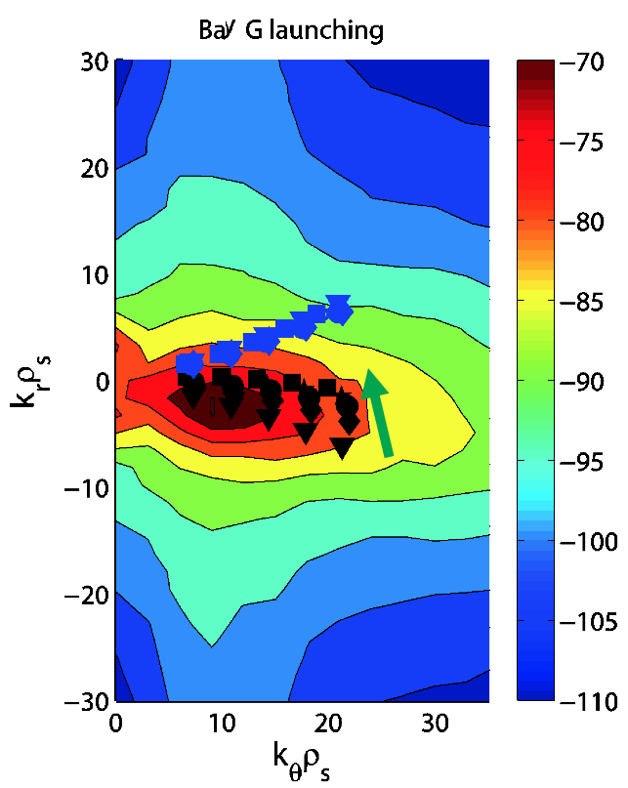

*Figure 3. The k-space distribution of the scattering wavenumbers of the upward (blue symbols) and downward (black symbols) scattering schemes for* = *10 to 30 cm-1 (every 5 cm-1) together with a simulated 2D spectrum of ETG turbulence in an NSTX NBI-heated H-mode plasma. The green arrow denotes the direction of increase in the radial direction: 1.19 m (downward-pointing triangle), 1.235 m (diamond), 1.28 m (circle), 1.325 m (pentagram),and 1.37 m (square).*

Utilizing this unique capability of the new high-kpoloidal scattering system, we will investigate the anisotropy in the 2D Wavenumber Spectrum in the extended regime offered by NSTX-U as in the collisionality scans detailed in Section 3.2 and studies on q profile and E x B shear dependence detailed in Sections 3.3 and 3.4, respectively (see below). This unique capability of measuring 2D wavenumber spectra provides new opportunities to extend and validate electron-scale turbulence theories and models.

**3.3 Study of q-profile dependence on electron-scale turbulence on NSTX-U**

The effect of q-profile on plasma confinement has been widely investigated in conventional tokamaks, where it demonstrated that magnetic shear (s) and q play a crucial role in ion temperature gradient (ITG) turbulence [[25](#_ENREF_25)]. For example, variations in s and q were found to account for up to 60% and 35% of ion transport, respectively, in JET and ASDEX Upgrade tokamaks, consistent with the linear threshold dependence of the ITG mode on s and q. Further experiments in these devices examined different s and q profiles in similar plasmas, where it was confirmed that changes in s and q significantly influence ITG-driven transport [[26](#_ENREF_26" \o "Citrin, 2012 #2324)]. A similar dependence on s and q has also been identified in the linear threshold of ETG modes [[27](#_ENREF_27)]. Since electron-scale turbulence may be more important in ST H-mode plasmas, it is important to study the q-profile dependence of electron-scale turbulence in NSTX-U.

The study of the q-profile dependence of electron-scale turbulence on NSTX-U will rely on the new high-k poloidal scattering system for detailed turbulence measurements. The variation of the q profile (thus the variation in s) will be achieved by varying BT, Ip, and NBI sources in combination in order to maintain other equilibrium quantities approximately constant:

1. Fixed NBI Power with BT and Ip scans: maintain constant NBI power while systematically varying BT and Ip to generate distinct q-profile variations.
2. Fixed Bₜ and Iₚ with NBI source scans: hold Bₜ and Iₚ constant while using different combinations of NBI sources to modify q-profiles. Keep q₉₅ (and optionally qₘᵢₙ) fixed, ensuring total NBI power remains unchanged.

While NBI alone introduces a coupling between the rotation profile and q-profile, external 3D coils offer a potential means to decouple these effects by actively controlling plasma rotation. This approach enables a clearer isolation of q-profile dependence of electron-scale turbulence in this study. The transport analysis code, TRANSP [[28](#_ENREF_28)], will be used to assess global confinement and local transport. Linear and nonlinear gyrokinetic simulations will be carried out using experimental profiles with gyrokinetic codes, e.g. GS2 [[29](#_ENREF_29)], for which PPPL will be able to provide sufficient support. The measured electron-scale turbulence will be correlated with transport analysis and comparison with nonlinear gyrokinetic simulations in both turbulence and transport will be carried out, providing valuable opportunities for code validation.

**3.4 Investigate effects of E x B shear on electron-scale turbulence in NSTX-U**

E x B shear has been recognized as a powerful mechanism to control plasma turbulence. It is well known that turbulence suppression by E x B shear occurs when the E x B shearing rate ($ω_{E×B}$) is comparable than the maximum linear growth rate ($γ_{max}$) of the underlying plasma instability, where a factor, ${α_{E}=ω}_{E×B}/γ_{max}$, can be used to characterize the ability of E x B shear to suppress turbulence as $α_{E}≈0.5$ can lead to the quenching of ion-scale turbulence [[30](#_ENREF_30)]. As for electron-scale turbulence, this suppression criterion also applies as having been observed in NSTX NBI-heated H-mode plasmas [[31](#_ENREF_31)]. On the other hand, electron-scale turbulence could also be affected indirectly by E x B shear if a portion of the electron-scale turbulence results from the nonlinear cascade from low-k turbulence or when significant nonlinear interaction between electron-scale and ion-scale turbulence is present, which is supported by observations in NSTX NBI-heated L-mode plasmas (see Fig. 4 ) [[32](#_ENREF_32)]. In these L-mode plasmas, 2 MW neutral beam injection (NBI) was employed in two phases: initially from 90-230 ms, followed by a second injection from 300 ms to discharge termination. During the second phase of NBI, the plasma toroidal rotation speed started to increase continuously, leading to a simultaneous increase in the E x B shearing rate in the outer half of the plasma. In Fig. 4 (a), $α_{E}$ at the location of turbulence measurement shows a gradual increase from t = 0.36 s to 0.45 s, which is due to the increase of $ω_{E×B}$, while the sharper increase of $α_{E}$ after t = 0.45 s is due to both the increase of $ω_{E×B}$ and decrease of $γ_{max}$ ( $ω_{E×B}$ is calculated using the Waltz-Miller definition as in Ref. [[33](#_ENREF_33)] and $γ_{max}$ is the maximum linear growth rate for ITG instability calculated with the GS2 gyrokinetic code). The measured $k_{⊥}$ spectra at corresponding time points the same as in Fig. 4 (a) are shown in Fig. 4 (b) (The high-k scattering system was configured to measure electron-scale turbulence for a $k_{⊥}ρ_{s}$ range of 2 to about 14 at about R ≈ 139 to 143 cm (r/a ≈ 0.67-0.73)). From t = 0.364 s to 0.398 s, the $k_{⊥}$ spectra have only small changes, while $α_{E}$ increases from about 0.2 to 0.26. A large decrease in spectral power at $k_{⊥}ρ_{s}<10$ occurs while $α_{E}$ approaches 0.4. It is important to note that the k spectra preserve their shape at $k_{⊥}ρ_{s}>10$ for t < 0.48 s only beyond which the spectral power at $k_{⊥}ρ_{s}>10$ also starts to decrease. This further decrease may be due to the large $α_{E}$ (≈0.8) achieved at t=0.48 s. The observed decrease in the electron-scale turbulence spectral power is unlikely due to the E x B shearing of ETG turbulence since although ETG modes are unstable for all times, their maximum linear growth rate could be more than a factor of 10 higher than the E x B shear rate. However, this observation is more consistent with numerical observation that the equilibrium E x B shear quenches the ion-scale turbulence when [[30](#_ENREF_30)]. Thus, we believe that some of the observed high-k electron-scale turbulence is nonlinearly driven by low-k ion-scale turbulence or there is significant nonlinear interaction between ITG and ETG turbulence, and thus, the electron-scale turbulence spectral power decreases as ion-scale turbulence are suppressed by the increasing E x B shear. Thermal transport reduction in both ion and electron channels is observed as measured turbulence power decreases. These observations show that even for electron-scale turbulence, E x B shear could potentially be utilized in the experiment to control it in order to improve energy confinement performance.

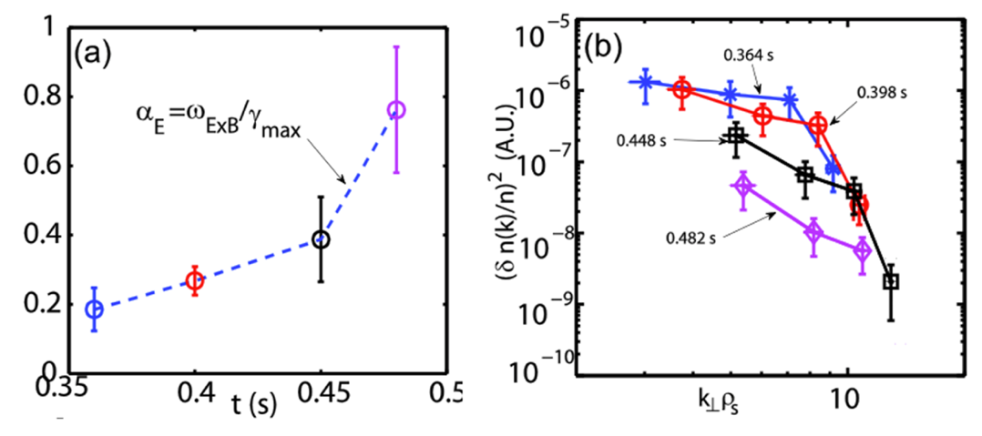

Figure 4. (a) The ratio between the E x B shear rate and the maximum linear growth rate for ITG modes; (b) $k_{⊥}$ spectra in arbitrary units at the four corresponding time points as in (a).

Based on the aforementioned observations in NSTX, our experimental approach on NSTX-U is to systematically vary E x B shear with combinations of different 2nd NBI sources coupled with external 3D coils in both NSTX-U L-mode and H-mode plasmas to investigate how electron-scale turbulence responds to variations of E x B shear. This method of coupling the 2nd NBI with external coils allows manipulation of the E x B shearing rate over a wide range, while simultaneous BT and Ip variations could help keep local s and q at turbulence measurement locations constant. Other equilibrium parameters, e.g. temperature and density profiles, could be modified or kept approximately constant with a carefully selected combination of any of the 6 sources from two NBIs. Studying E x B shear effects in both L- and H-mode plasmas will help us distinguish different regimes of E x B shear effect on electron-scale turbulence: direct shearing of ETG eddies by E x B shear versus indirect effects through nonlinear cascade and/or nonlinear interaction between electron and ion-scale turbulence. Experimental results will be compared with linear/nonlinear gyrokinetic simulations (multi-scale simulations if needed) to validate theory and numerical modeling. These comparisons will not only test code predictions against measured transport in the presence of E x B shear, but also help clarify the relative roles of ion- and electron-scale turbulence in governing electron thermal transport in ST L-mode and H-mode plasmas.

In brief summary, this study addresses critical challenges concerning the understanding E x B shear effects on electron-scale turbulence and how to control it in the present and future devices. We aim to (1) quantify E x B shear effects on electron-scale turbulence with and without the presence of ion-scale turbulence; (2) quantify the parametric regime where E x B shear could be used to suppress electron-scale turbulence; (3) explore the existence of an optimal E x B shearing rate to minimize electron thermal transport given the theoretically-predicted nonlinear connections between electron and ion-scale turbulence. This study employs coordinated experimental measurements and gyrokinetic simulations to establish quantitative relationships between shearing rates, multi-scale turbulence interaction, and consequent transport modifications.

**3.5 FPGA calculates the FIReTIP diagnostics signal for low latency real-time density measurement with mechanical motion corrections**

The NSTX-U 5-Year Plan (2026–2030) aims to extend plasma confinement into new regimes, including low aspect ratio, high-beta operation at lower collisionality, innovative power and particle handling in high-performance scenarios, and non-inductive, low-disruption steady-state operation. Achieving these research objectives requires an advanced plasma control system capable of real-time feedback control. The Far Infrared Tangential Interferometer/Polarimeter (FIReTIP) has been developed as a critical diagnostic system for density feedback control and machine protection on NSTX-U.

The FIReTIP is a laser-based plasma diagnostic [[5](#_ENREF_5)] that utilizes two co-propagating, circularly polarized probe beams (λ = 119 μm) from two FIR lasers, with a third laser serving as a reference . The probe beams follow a fixed path from Bay G to Bay B, where a retroreflector redirects them back along the same trajectory, enabling double-pass plasma measurements. After passing through the plasma, the returning FIReTIP signals are combined with the reference beam in mixers near Bay G. These signals are down-converted to RF frequencies and processed by back-end electronics to produce separate interferometer and polarimeter outputs. By exploiting the frequency difference between the two probe beams, their respective plasma-induced phase shifts are independently measured—the average phase shift provides the interferometer signal (line-integrated density), while the difference yields twice the Faraday rotation angle.

A dedicated field-programmable gate array (FPGA) operates in parallel with the diagnostic digitizers to perform real-time analysis. The FPGA corrects FIReTIP data for mechanical vibrations (detected via a co-propagating HeNe interferometer) and delivers a fringe-jump-corrected output to the NSTX-U Real-Time Control and Protection (RTCP) system with minimal delay. This capability enables real-time density feedback control and supports EFIT equilibrium reconstructions as a constraint.



*Figure. 5. In the NSTX-U tokamak, the Far Infrared (FIR) laser beams follow a tangential path for plasma diagnostics. The beams are launched from Bay G, propagate through the plasma, and reflect off a mirror located at Bay B. After reflection, they travel back along the same path to Bay G.*

4. Project Timeline

This five-year program focuses on NSTX-U plasma electron-scale turbulence and transport physics and machine safety operations using the poloidal high-k scattering diagnostic and FIReTIP. The first year prioritizes diagnostic implementation, ensuring both systems are operational from **Day 1** of NSTX-U experiments through hardware installation, remote-operation software interfaces, and synthetic diagnostics development. Following deployment, efforts shift toward enhancing high-k capabilities—expanding synthetic diagnostics/modules and optimizing FIReTIP’s density feedback control in collaboration with PPPL. Once NSTX-U achieves first plasmas, the focus transitions to physics studies (Year 2 - 5), while maintaining diagnostics during non-run periods. A detailed timeline is provided below.

1. **Study collisionality dependence of electron-scale turbulence utilizing the extended collisionalilty regime of NSTX-U)**
2. Poloidal high-k scattering (key diagnostics) installation and calibration on NSTX-U (Year 1)
3. Synthetic high-k diagnostics module development for theorical model validation with NSTX and NSTX-U experimental data (Year 1 Q2 to Q4)
4. Synthetic diagnostics database establishment with NSTX-U plasma scenarios (Year 2 to Year 5, 2 quarters each year)
5. Electron-scale turbulence measurements during NSTX-U physics campaigns (NSTX-U first plasma to Year 5 Q3)
6. Electron-scale turbulence experimental data interpretation and transport model validation (Year 2 Q3 to Year 5 Q3)
7. Object report (Year 5 Q4)
8. **Study the ETG streamer with 2D wavenumber spectrum measurement**
9. Synthetic database establishment for ETG streamer with NSTX-U plasma scenarios (Year 2 Q1 and Q2, Year 3 Q1 and Q2)
10. 2D wavenumber measurement during NSTX-U physics campaigns (Year 2 Q3 to Year 4 Q3)
11. ETG streamer wavenumber data interpretation (Year 2 Q4 to Year 5 Q1)
12. Object report (Year 5 Q2 and Q3)
13. **Study q-profile dependence on electron-scale turbulence on NSTXT-U**
14. Synthetic database establishment with different q-profiles scenarios based on NSTX-U plasma (Year 2 Q1 and Q2, Year 3 Q1 and Q2)
15. Electron-scale turbulence measurement by scanning q95 and modifying qmin (Year 2 Q3 to Year 5 Q3)
16. NSTX-U experimental data interpretation and theorical model validation (Year 2 Q3 to Year 5 Q3)
17. Objective report (Year 5 Q4)
18. **Investigate effects of E x B shear on electron-scale turbulence in NSTX-U**
19. Synthetic database establishment based different E x B ratio on NSTX-U plasma (Year 2 Q1 and Q2, Year 3 Q1 and Q2)
20. Electron-scale turbulence measurement by scanning E x B ratio (Year 2 Q4 to Year 5 Q3)
21. NSTX-U experimental data interpretation and theorical model validation (Year 2 Q4 to Year 5 Q3)
22. Objective report (Year 5 Q4)
23. **FPGA calculates the FIReTIP diagnostics signal for low latency real-time density measurement with mechanical motion corrections**
24. FIReTIP (key diagnostics) installation and calibration on NSTX-U (Year 1)
25. Preliminary testing result without plasma (Year 2 Q1 to NSTX-U first plasma)
26. FIReTIP pre-testing with NSTX-U startup plasma (NSTX-U first plasma to Year 2 Q2)
27. FIReTIP real-time density measurement for RTCP on NSTX-U (NSTX-U first plasma to Year 5 Q4)
28. Objective report (Year 5 Q4)

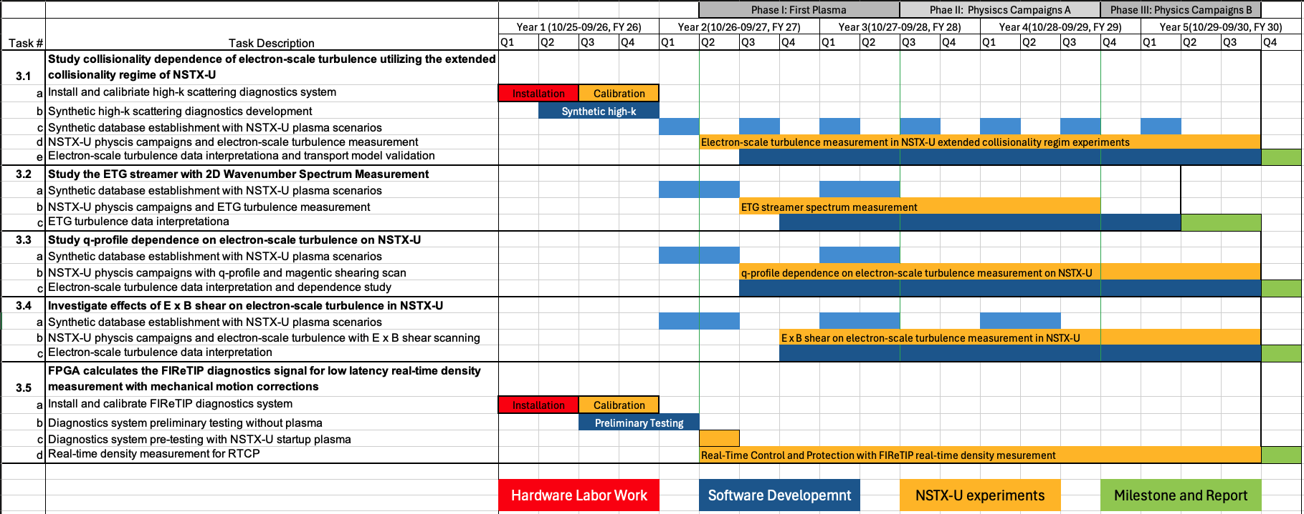

**APPENDIX I: BIBLIOGRAPHY & REFERENCES CITED**

1. Menard, J., et al. "Overview of the physics and engineering design of NSTX upgrade." Nuclear Fusion 52(8) (2012): 083015.

2. Kaye, S., et al. "The dependence of H-mode energy confinement and transport on collisionality in NSTX." Nuclear Fusion 53(6) (2013): 063005.

3. Guttenfelder, W., et al. "NSTX-U theory, modeling and analysis results." Nuclear Fusion 62(4) (2022): 042023.

4. Barchfeld, R., et al. "The high-k poloidal scattering system for NSTX-U." Review of Scientific Instruments 89(10) (2018):

5. Scott, E., et al. "Far-infrared tangential interferometer/polarimeter design and installation for NSTX-U." Review of Scientific Instruments 87(11) (2016):

6. Dorland, W., et al. "Electron temperature gradient turbulence." Physical Review Letters 85(26) (2000): 5579.

7. Jenko, F., et al. "Electron temperature gradient driven turbulence." Physics of Plasmas 7(5) (2000): 1904-1910.

8. Ren, Y., et al. "Recent progress in understanding electron thermal transport in NSTX." Nuclear Fusion 57(7) (2017): 072002.

9. Told, D., Gyrokinetic microturbulence in transport barriers. 2012, University of Ulm: Ph.D. thesis.

10. Guttenfelder, W., et al. "Testing predictions of electron scale turbulent pedestal transport in two DIII-D ELMy H-modes." Nuclear Fusion 61(5) (2021): 056005.

11. Hatch, D., et al. "A gyrokinetic perspective on the JET-ILW pedestal." Nuclear Fusion 57(3) (2017): 036020.

12. Ren, Y., et al. "Experimental study of parametric dependence of electron-scale turbulence in a spherical tokamak." Physics of Plasmas 19(5) (2012):

13. Ren, Y., et al. "Density Gradient Stabilization of Electron Temperature Gradient Driven Turbulence<? format?> in a Spherical Tokamak." Physical Review Letters 106(16) (2011): 165005.

14. Smith, D., et al. "A collective scattering system for measuring electron gyroscale fluctuations on the National Spherical Torus Experiment." Review of Scientific Instruments 79(12) (2008):

15. Ren, Y., et al. "Transport from electron-scale turbulence in toroidal magnetic confinement devices." Reviews of Modern Plasma Physics 8(1) (2024): 5.

16. Valovič, M., et al. "Collisionality and safety factor scalings of H-mode energy transport in the MAST spherical tokamak." Nuclear Fusion 51(7) (2011): 073045.

17. Kaye, S., et al. "Scaling of electron and ion transport in the high-power spherical torus NSTX." Physical Review Letters 98(17) (2007): 175002.

18. ITER, E. "Overview and summary." Nuclear Fusion 39(12 ITER physics basis) (1999): 2137-2174.

19. Guttenfelder, W., et al. "Electromagnetic transport from microtearing mode turbulence." Physical Review Letters 106(15) (2011): 155004.

20. Colyer, G., et al. "Collisionality scaling of the electron heat flux in ETG turbulence." Plasma Physics and Controlled Fusion 59(5) (2017): 055002.

21. Kim, E.-j., C. Holland, and P. Diamond. "Collisional damping of ETG-mode-driven zonal flows." Physical Review Letters 91(7) (2003): 075003.

22. Parker, S.E., et al. Fine‐Scale Zonal Flow Suppression of Electron Temperature Gradient Turbulence. in AIP Conference Proceedings. 2006. American Institute of Physics.

23. Wang, W., et al. "Identification of new turbulence contributions to plasma transport and confinement in spherical tokamak regime." Physics of Plasmas 22(10) (2015):

24. Chapman-Oplopoiou, B., et al. "Composition of electron temperature gradient driven plasma turbulence in JET-ILW tokamak plasmas." Physical Review Research 7(1) (2025): L012004.

25. Citrin, J., et al. "Predictive analysis of profile influence on transport in JET and ASDEX Upgrade hybrid scenarios." Plasma Physics and Controlled Fusion 54(6) (2012): Artn 065008 10.1088/0741-3335/54/6/065008/<Go to ISI>://WOS:000304440800008.

26. Citrin, J., et al. "Predictive analysis of q-profile influence on transport in JET and ASDEX Upgrade hybrid scenarios." Plasma Physics and Controlled Fusion 54(6) (2012): 065008.

27. Jenko, F., W. Dorland, and G. Hammett. "Critical gradient formula for toroidal electron temperature gradient modes." Physics of Plasmas 8(9) (2001): 4096-4104.

28. Hawryluk, R., An empirical approach to tokamak transport, in Physics of plasmas close to thermonuclear conditions. 1981, Elsevier. p. 19-46.

29. Kotschenreuther, M., G. Rewoldt, and W. Tang. "Comparison of initial value and eigenvalue codes for kinetic toroidal plasma instabilities." Computer Physics Communications 88(2-3) (1995): 128-140.

30. Kinsey, J., R. Waltz, and J. Candy. "The effect of plasma shaping on turbulent transport and E× B shear quenching in nonlinear gyrokinetic simulations." Physics of Plasmas 14(10) (2007):

31. Smith, D., et al. "Observations of reduced electron gyroscale fluctuations in national spherical torus experiment h-mode plasmas with large e× b flow shear." Physical Review Letters 102(22) (2009): 225005.

32. Ren, Y., et al. "Electron-scale turbulence spectra and plasma thermal transport responding to continuous E× B shear ramp-up in a spherical tokamak." Nuclear Fusion 53(8) (2013): 083007.

33. Waltz, R. and R. Miller. "Ion temperature gradient turbulence simulations and plasma flux surface shape." Physics of Plasmas 6(11) (1999): 4265-4271.

**APPENDIX II: FACILITIES AND OTHER RESOURCES**

**Overview**

The proposed “Understand/Control the Electron-Scale Turbulence and Achieve Reliable Real-time Density Measurement: Enhancing Confinement and Controllability on NSTX-U” activity submitted under: DE-FOA-0003432 draws heavily on the experience and resources of the Principal Investigator’s group. As discussed in detail in the Technical Narrative, the electron-scale turbulence understanding study employs the NSTX-U 693 GHz high-k poloidal scattering diagnostics. The reliable real-time density measurement for confinement improvements employs the NSTX-U 2.5 THz FIReTIP diagnostics. Both of these were developed under the previous Grant (DE-SC0021353 and DE-FG02-99ER54518) and are being shipped to PPPL for installation and Day #1 operation on NSTX-U.

**Princeton Plasma Physics Laboratory, NSTX-Upgrade Facility**

The National Spherical Torus Experiment-Upgrade (NSTX-U) is an advanced magnetic fusion research facility located at the Princeton Plasma Physics Laboratory (PPPL) in Princeton, New Jersey. As a spherical tokamak, NSTX-U differs from conventional tokamak designs by having a more compact, “cored-apple” shape, which allows for higher beta plasma pressure relative to the magnetic field strength. This configuration holds promise for more efficient and economically viable fusion power plants. The facility underwent a major upgrade, including a more powerful central solenoid for driving higher plasma current, new neutral beam injectors for increased heating and current drive, and improved magnetic coils to enable longer plasma pulses. NSTX-U can achieve 1 T magnetic fields and 2 MA plasma currents, making it one of the most powerful spherical tokamaks in the world.

NSTX-U serves as one of the most important platforms for exploring key challenges in fusion energy science, such as plasma stability, confinement, and heat management in compact devices. The research conducted on NSTX-U supports the development of next-generation fusion reactors, including conceptual designs for spherical tokamak-based pilot plants. Additionally, its findings contribute to international fusion efforts, such as ITER, by providing complementary data on plasma behavior in alternative geometries. Although NSTX-U encountered technical setbacks shortly after its upgrade, leading to a temporary shutdown for repairs and component redesigns, its mission remains vital to the long-term goal of achieving practical and sustainable fusion energy. Once fully operational, NSTX-U will continue to push the boundaries of fusion science and engineering, helping to pave the way toward clean, safe, and virtually limitless energy. The NSTX-U device is the flagship of the Compact Toroidal Concepts (CTC) endeavor with the following official Objectives:

*Objective 1: Extend confinement and stability physics basis at low-A and high beta to lower collisionality*

*Objective 2: Develop and evaluate conventional and innovative power and particle handling techniques to optimize plasma exhaust in high performance scenarios*

*Objective 3: Develop core-edge integrated operation at large bootstrap fraction and advance the physics basis required for non-inductive and low-disruptivity operation of steady-state compact fusion devices*

The UC Davis developed diagnostics instruments (Far IR Tangential Interferometer / Polarimeter and High-k Scattering ex-vessel) will find application in support of all three objectives. For example, Sec. 3 (Proposed Research and Methods) provides detailed discussions of the envisioned physics issues associated with turbulence. Here, it is envisioned that repairs or modifications will be carried out at UC Davis and subsequently the components sent to NSTX-U for on-site installation although in the event of a major disaster the constituent pieces could be sent to Davis where there are facilities to solve any issue.

**University of California at Davis, Davis Millimeter-wave Research Center Facility**

UC Davis offers one of the most comprehensive collections of microwave, millimeter-wave, and THz equipment available. The proposed NSTX-U work will be supported by state-of-the-art laboratory facilities, including the Davis Millimeter-wave Research Center (DMRC) measurement laboratory in Ghausi Hall, an anechoic chamber, and a recently upgraded microfabrication facility in Kemper Hall. Additionally, the PI’s Millimeter-Wave Plasma Diagnostics Group (MMPDG) operates a dedicated facility on Spafford Road. The Investigator’s primary laboratory is a 12,000 ASF facility on Spafford Road, located just off campus (see Fig. 1).

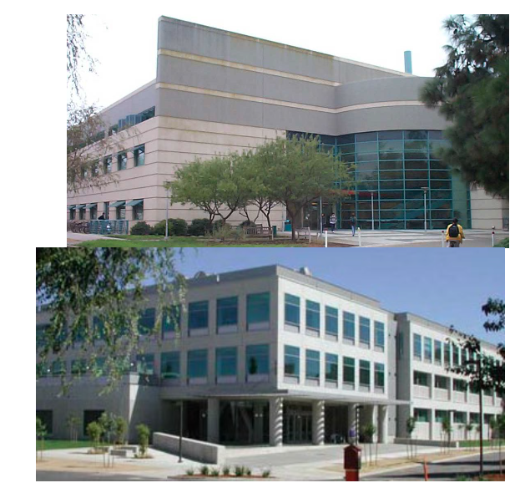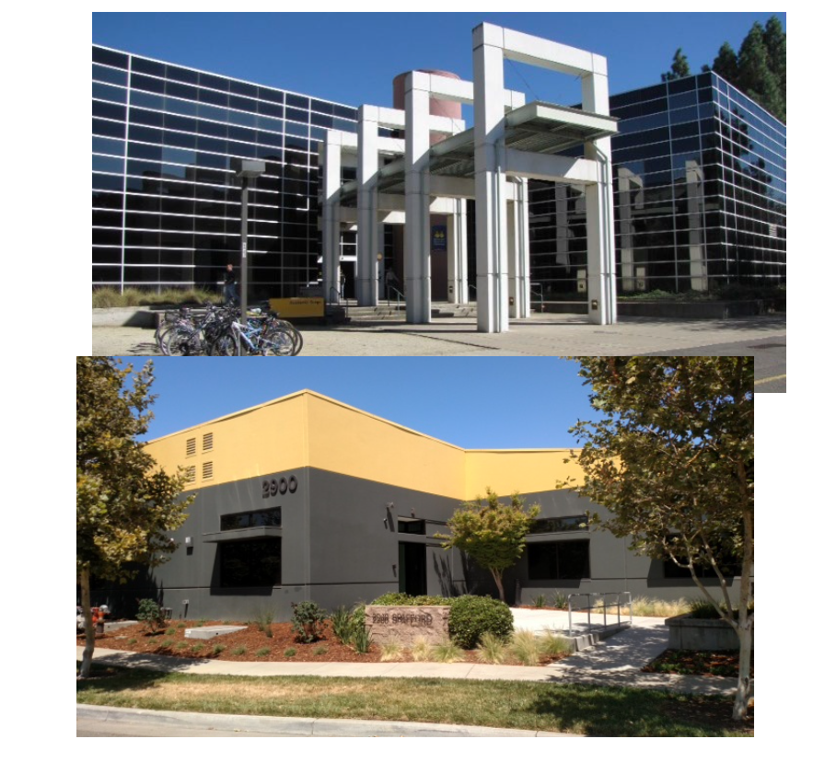

*Figure 1. Photographs of the Kemper Hall and Ghausi Hall buildings (left). Photographs of the Academic Surge building, and Spafford Rd, facility (right).*

**2.2 Laboratory Facilities**

**2.2.1 Calibration and Alignment Laboratory (PPPL)**

The high-k poloidal scattering and FIReTIP diagnostic systems require periodic maintenance and calibration to ensure optimal performance. PPPL maintains a comprehensive calibration and alignment laboratory facility to support these needs. The D253 laboratory space (more space available) is specifically utilized for optical bench alignment of diagnostic components, signal strength optimization, and electromagnetic interference mitigation - all of which contribute to enhanced signal-to-noise ratios crucial for accurate electron-scale turbulence measurements and data interpretation. A dedicated laser cage area (see Fig. 2) serves as the primary operational site for these diagnostics, housing both the 693 GHz transmitter for electron-scale turbulence studies and the 2.5 THz FIReTIP transmitter system used for NSTX-U density measurements and real-time plasma control applications. This integrated facility enables precise calibration, testing, and deployment of these major millimeter-wave and terahertz diagnostic systems.

 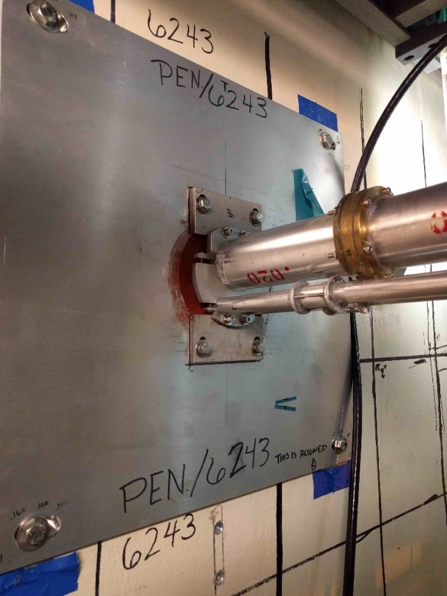

*Figure 2. Photograph of the FIReTIP lasers and supply installed on NSTX-U (left), and the wall penetration that allows the FIReTIP and High-k Scattering beams to pass through the wall to reach NSTX-U (right).*

**2.2.2 Keysight Technologies Testing Laboratory (1117 Ghausi Hall)**

Both high-k poloidal scattering and FIReTIP diagnostics require precise laboratory calibration for response testing of mm-wave and terahertz components (1–20 GHz, 680–700 GHz, and 2.5 THz). In collaboration with Keysight Technologies the DMRC has developed a state-of-the-art core test facility (see Fig. 3) equipped with microwave and millimeter-wave measurement capabilities extending up to 325 GHz. This facility features a $1.5 million Agilent nonlinear vector network analyzer (PNA-X) and spectrum analysis test equipment (PXA), and additional test facilities. In addition to the abovementioned instrumentation, the DMRC is well equipped with two wafer probe stations with Cascade Microtech, Inc. probes extending to 360 GHz, an additional PNA, N1913PM5B Virginia Diodes, Inc./Erickson PM5B calorimetric mm-wave power meter, Agilent signal generators, and spectrum analyzers. Higher frequency (THz) testing measurements are carried out in our Spafford Road facility (see Sec. 2.2.3).

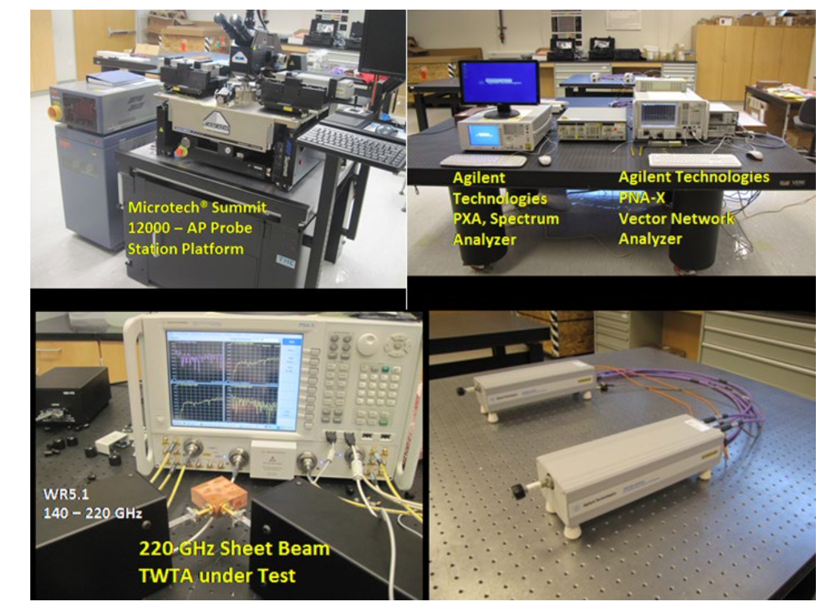

*Figure 3. (Upper left) Microtech Summit 12000-AP semi-automatic Probe Station Platform. (Upper right) DMRC Lab with microwave/millimeter-wave measurement capabilities up to 325 GHz. (Bottom left) 220 GHz Sheet Beam Travelling Wave Tube Amplifier under test. (Bottom right) Waveguide T/R module (frequency extenders) N5260-60004, 67 – 110 GHz.*

**2.2.3 Fusion Plasma Diagnostics, and Millimeter-wave/Terahertz Instrumentation Laboratory (2900 Spafford Rd.)**

The plasma diagnostics development and testing are conducted in Prof. Luhmann’s 12,000 ASF Spafford Road Laboratory (see Fig. 4). This facility, located just 2.4 miles from the main campus, houses key millimeter-wave and THz resources from the Davis Millimeter Wave Research Center (DMRC).

This state-of-the-art facility includes a cleanroom, a chemistry room with three fume hoods, and six high-temperature hydrogen ovens. It also features a dedicated machine shop equipped with standard machining tools, two high-precision machining centers, and on-site capabilities for rapid prototyping and part fabrication. The shop includes both laser and TIG welding facilities, ensuring quick and efficient repairs or custom part production without outsourcing. A particularly significant addition to the Spafford facility is the inclusion of three nano-CNC machines, essential for developing near-THz devices. This expansion builds upon a highly productive seven-year collaboration with DMG-Mori, one of the world’s largest machine tool manufacturers. Through this partnership, DMRC had exclusive access to a prototype NN1000 nano-CNC machine, capable of fabricating micron-scale parts with nanometer-level precision, comparable to microfabrication technologies.



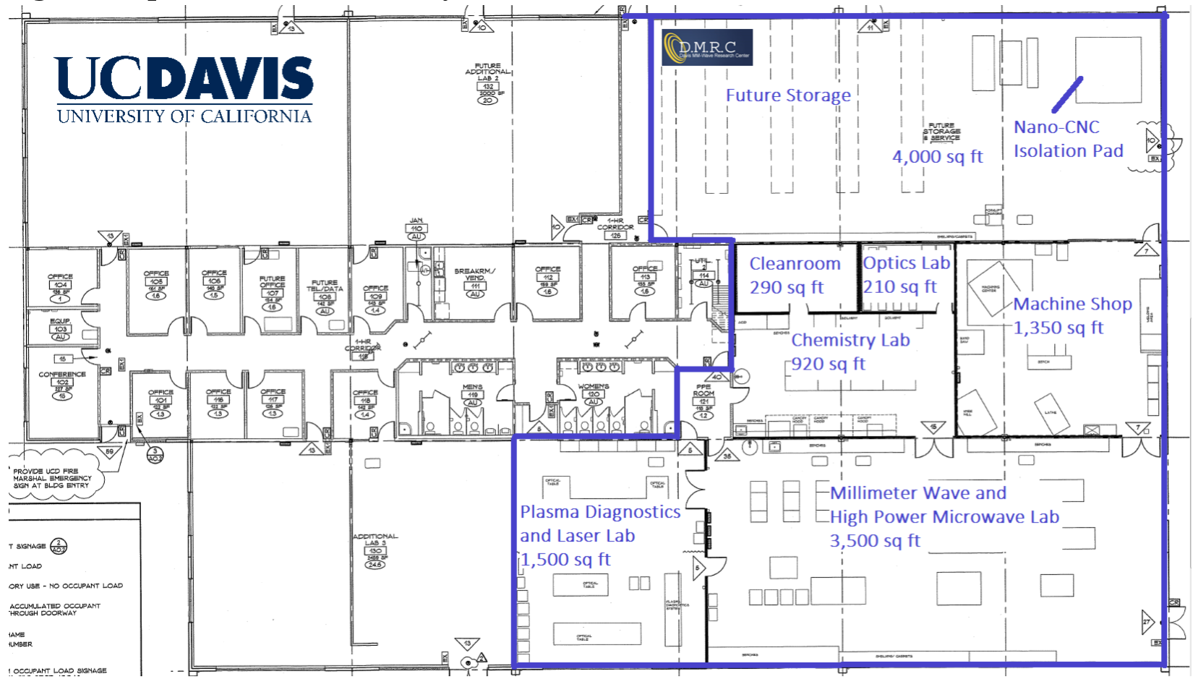

*Figure 4. 2900 Spafford Rd. Laboratory at Davis city, CA. Spafford Road facility layout; note the isolation pad specifically prepared for the Nano-CNC Machines used in near-THz device fabrication.*

The Spafford facility’s machining capabilities were significantly enhanced by DMG-Mori’s donation of three nano-CNC machines, each valued at approximately $1.5 million. These high-precision, high-productivity 5-axis CNC mills offer sub-micron tolerance (<50 nm/100 mm position error) and surface roughness on the scale of tens of nanometers. A new Kern Pyramid Nano precision CNC Machining Centre which is a high productivity ultra-precision 5-axis CNC mill with 0.5 µm tolerance capabilities. The Kern Pyramid Nano CNC machining center (see Fig. 5) offers micro- and nano- fabrication capabilities and is well suited for the fabrication of high precision THz electronic devices. Complete support capability ranging from preparation to final measurement is provided at the Spafford facility.

*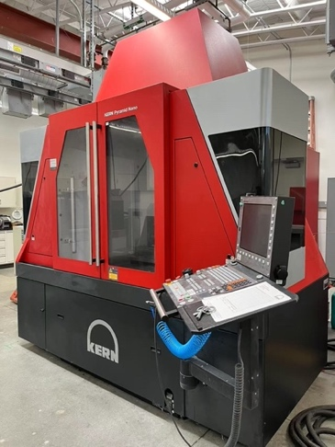 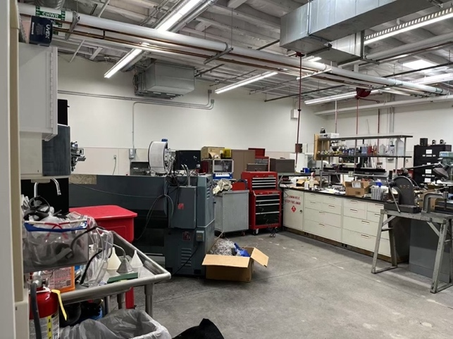*

*Figure 5. Nano-CNC Machines: the Kern Pyramid Nano CNC (left), and machine shop (right).*

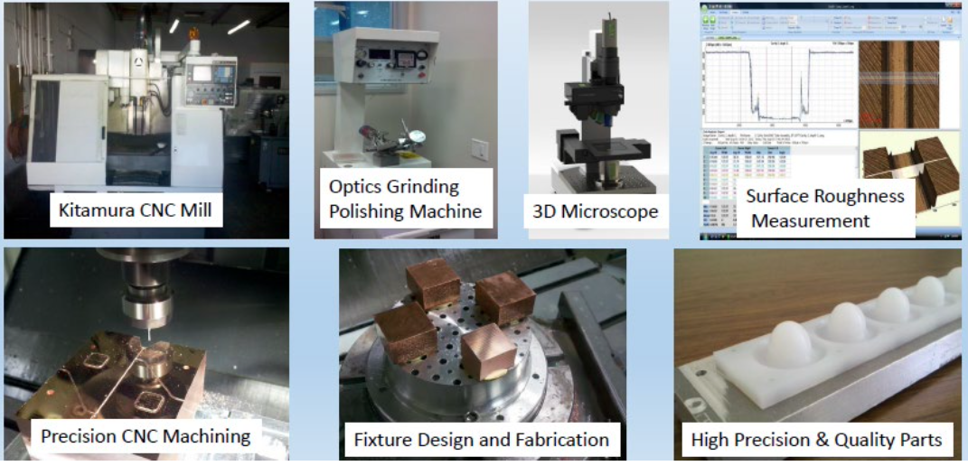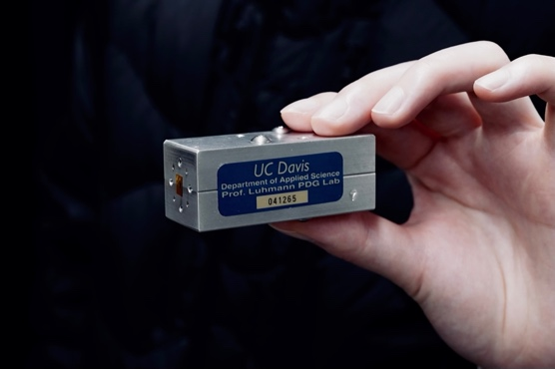

*Figure 6. Nano-CNC support for millimeter-wave diagnostics components (left), in-house developed front-end filter for millimeter-wave diagnostics.*

The Spafford facility also has a separate magnetic fusion plasma diagnostics laboratory area established to provide novel diagnostics instrumentation for next generation magnetic fusion plasma devices. Recent developments have focused on active/passive millimeter-wave diagnostic instruments for density and temperature fluctuations on tokamak fusion devices around the world: DIII-D, NSTX-Upgrade, ASDEX-Upgrade, Wendelstein 7-X, and more. The large optical tables and computerized microwave/millimeter-wave test equipment are available for plasma diagnostics development, including a transmitter and receiver pattern testing platform (see Fig. 7). Optical characterizations, including focal plane pattern measurements are performed with a 3D motorizied translation stage coupled with a large aperture mechanical light chopper for hot-cold receiver calibration. The Spafford facility has considerable development and test equipment specifically tailored to the development and characterization of each element of the high-k poloidal scattering and FIReTIP instruments.

*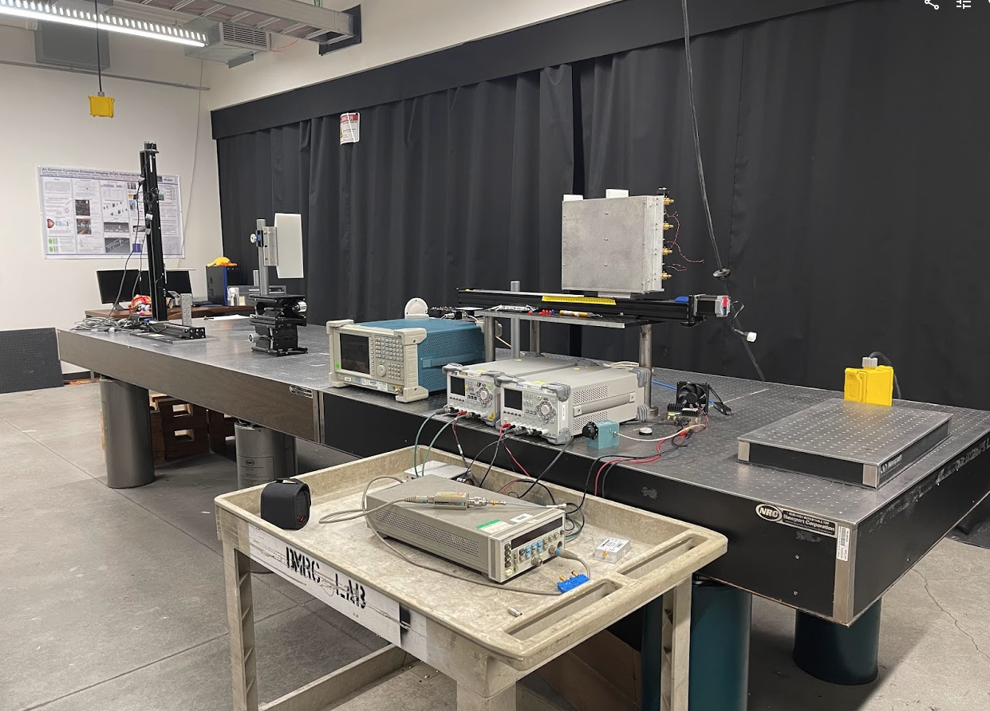 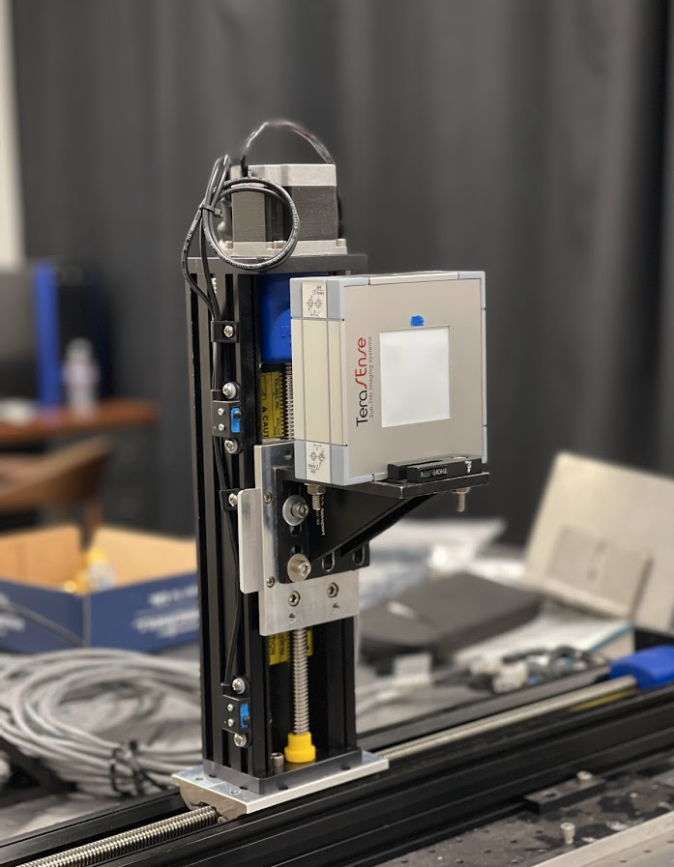*

*Figure 7. Terahertz transmitter and receiver pattern testing platform (receivers and terahertz camera).*

As noted in the facility overview (see Fig. 4), a laser laboratory is also part of the complex and has been used for the development of far-infrared laser interferometers, polarimeter instruments, and collective scattering systems for fusion plasma diagnostics (see Fig.8-10). Both laboratory areas are equipped with a range of instrumentation—from calorimetric power meters to waveguide components—that support vacuum electronic device (VED) testing. Referring back to the facility outline, there is also a laser laboratory which has been utilized for the development of far-infrared laser interferometers and polarimeter instruments and collective scattering systems for fusion plasma devices (see Fig. 11). The diagnostics instrumentation ranging from calorimetric power meters to waveguide components exist in both facilities and facilitate vacuum electronics device testing.

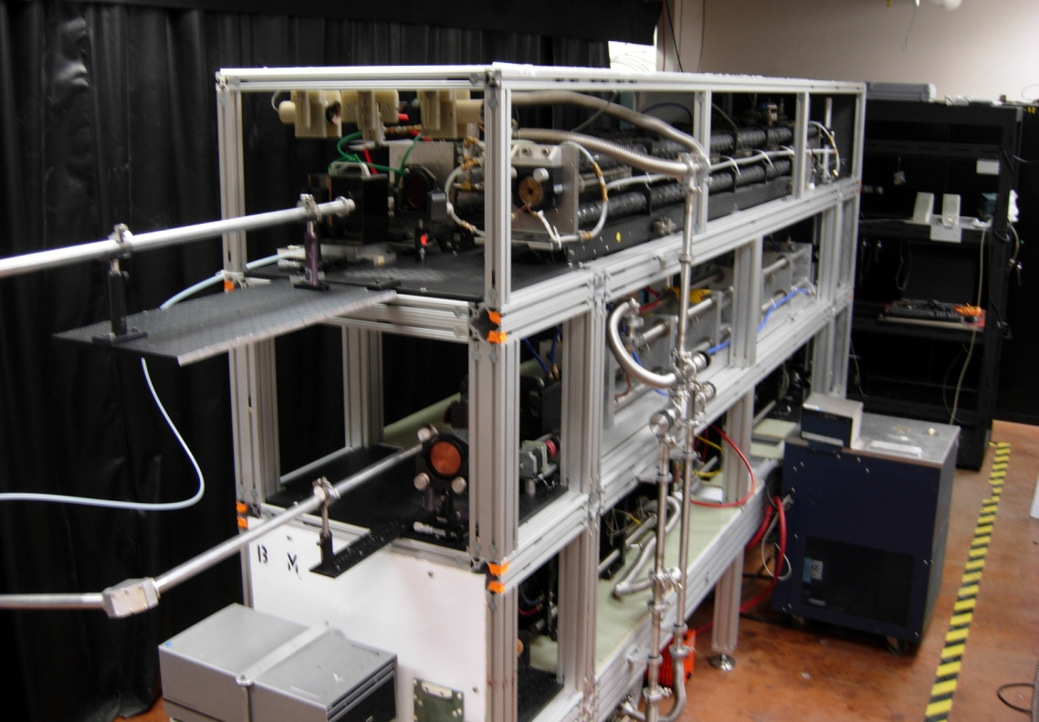

*Figure 8. Laser table with Lexan enclosure removed. The overall dimensions are 144" long, 28" wide, and 84" tall. The four FIReTIP lasers are installed; however, the High-k Scattering lasers will be installed.*

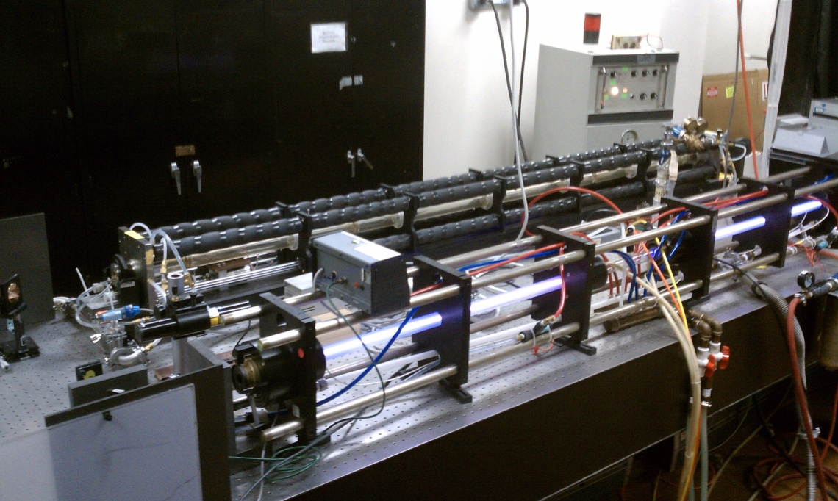

*Figure 9. CO2 and Methanol lasers. The CO2 laser is in the foreground. The laser is currently energized as evidenced by the waveguide glowing purple.*

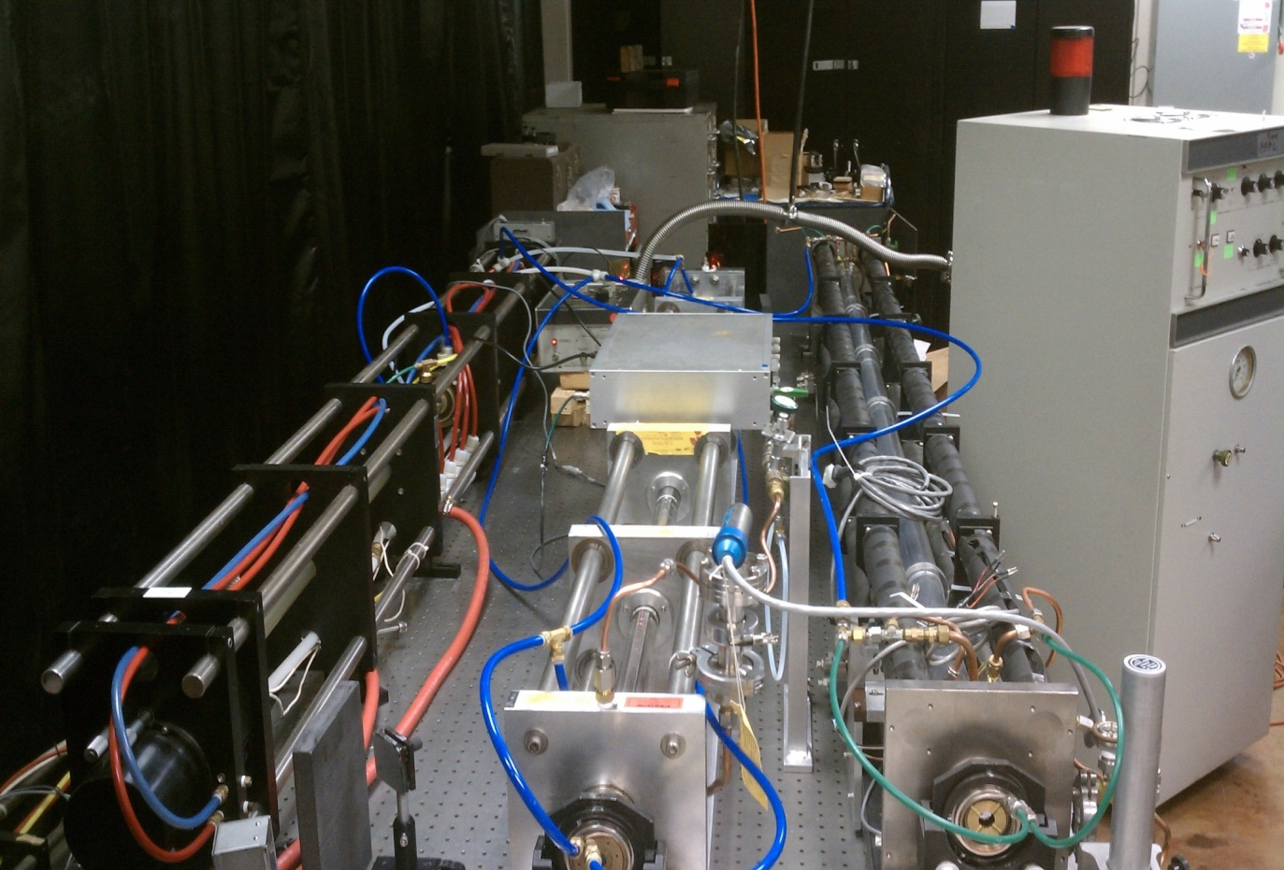

*Figure 10. FIReTIP laser’s types shown together. From left to right, CO2 laser, Stark FIR laser, and FIR laser.*

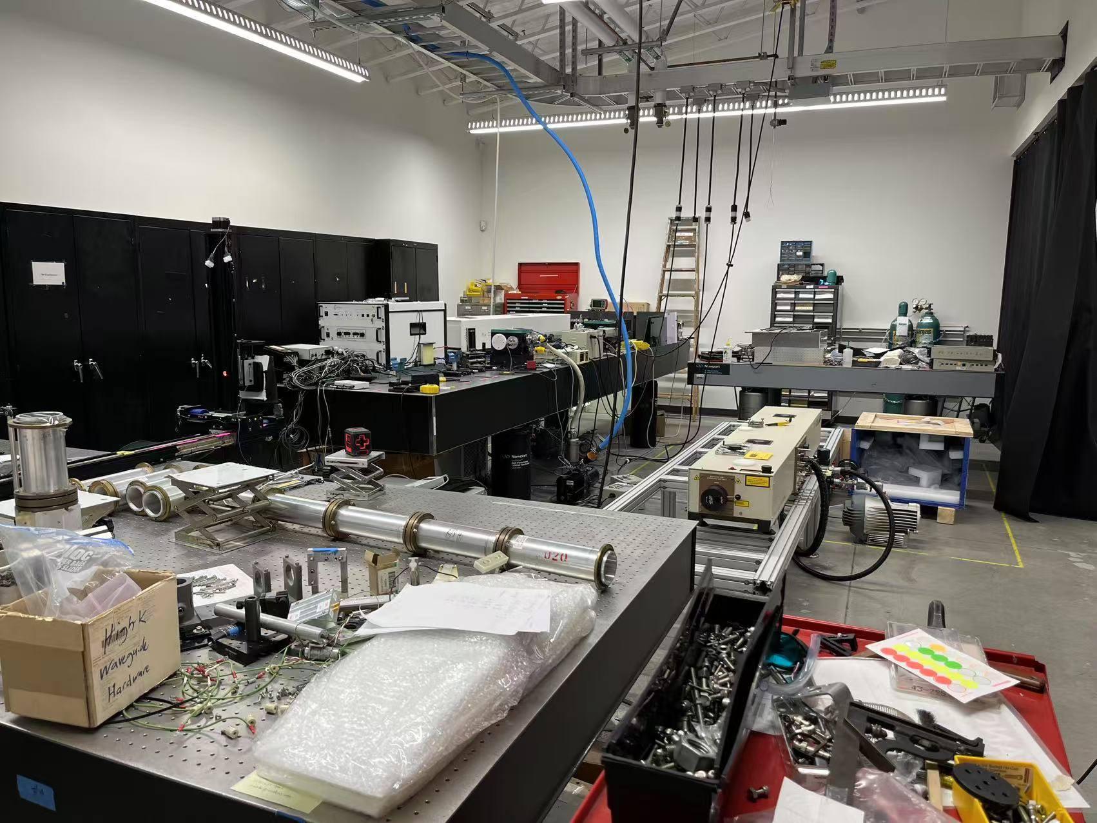

*Figure 11. Laser-based plasma diagnostic instrument platform in Spafford facility, Davis, CA.*

**2.2.4 Computing Facility for Synthetic Diagnostics Development, NSTX-U Modeling and Data Interpretation (Academic Surge)**

The PI’s computer facility is housed in the Academic Surge Building, providing office space for R&D staff, graduate students, and visiting scholars, along with an adjacent dedicated computer facility equipped with tele- and video-conferencing capabilities. The group possesses advanced millimeter-wave/THz beam propagation simulation tools that play a critical role in NSTX-U real-time feedback control, turbulence physics studies, and experimental data interpretation. During the previous funding period (FY20–FY25), a synthetic diagnostics module has been developed, offering high-precision beam tracing calculations for transmitter and receiver beam propagation in NSTX-U plasmas. This module bridges simulation and experimental data through forward modeling (examples, see Figs. 12 -13). Additionally, FPGA-based real-time density measurements will be trained and optimized in the computing facility to enable low-latency, high-accuracy feedback control for NSTX-U operations.

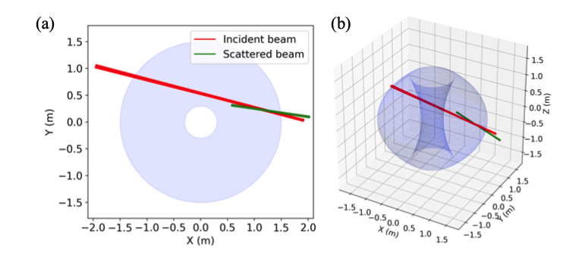

*Figure 12. Beam trajectory in NSTX (shot #141716 at t = 498 ms) with (a) shows the beam trajectory projection on the mid-plane, (b) representation in 3D of the beam in the NSTX tokamak.*

*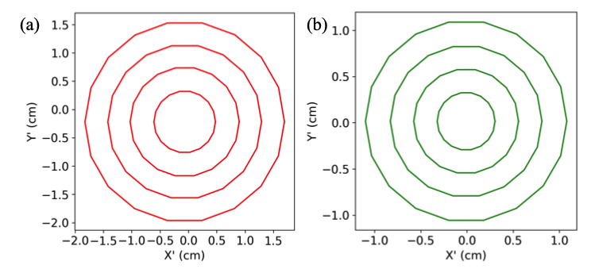*

*Figure 13. Beam cross sections at the interaction region for NSTX-U high-k scattering, shown in the beam reference coordinates with (a) incident beam cross section, (b) scattered beam cross section.*

**APPENDIX III: EQUIPMENT**

UC Davis brings substantial equipment to the proposed “Understand/Control the Electron-Scale Turbulence and Achieve Reliable Real-time Density Measurement: Enhancing Confinement and Controllability on NSTX-U” activity submitted under: DE-FOA-0003432. The primary diagnostic systems—the high-k poloidal scattering system and the FIReTIP system—will be used to investigate electron-scale turbulence and to provide reliable real-time density measurements, respectively. The specific components of each system are listed below.

1. **FIR Laser System for High-k Diagnostic and FIReTIP on NSTX-U:** The FIR laser-based plasma diagnostics system planned for NSTX-U has been integrated into a custom-designed, three-level laser tower (see Fig. 1) built specifically for deployment on the device. As part of an ongoing upgrade, a new CO₂ laser and a solid-state laser power supply have been purchased from Edinburgh Instruments (see Fig. 2) to replace one of the existing CO₂ lasers currently used in the high-k diagnostic system.



Figure 1. Photograph of a three-level laser tower that will house two CO2 lasers and four FIR lasers for FIReTIP and the high-k poloidal scattering system.



Figure 2. Photograph of a PL6 laser with its protective cover removed, power supply and gas cylinder containing CO2-N2-He gas.

Also included with these laser systems are power meters, laser interferometers, recirculating chillers, and a 3D scanning pyroelectric detector-based beam profiling system (see Fig. 3). Data acquisition hardware brought to this proposal includes 32 channels of 12 MS/sec @ 14-bit and 64 channels of 2 MS/sec @ 14-bit digitizers. The high-k scattering electronics (see Fig. 4 for the layout) will be upgraded to support higher modulation frequencies (but will retain the same high-performance low noise amplifiers). The fundamental design and operation of the IF electronics are unchanged from the previous High-k scattering design; however, the design will be updated for increased band width, higher sampling rate, and eight receiving channels.

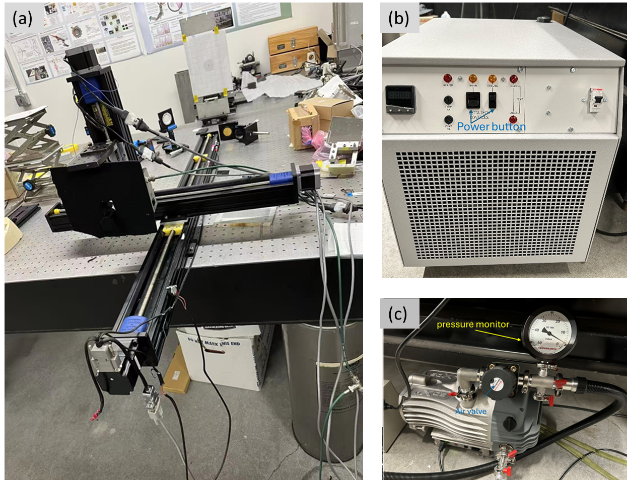

Figure 3. (a) Photos of a computerized 3D beam scanner, (b) a recirculating chiller, (c) pump and pressure monitor.

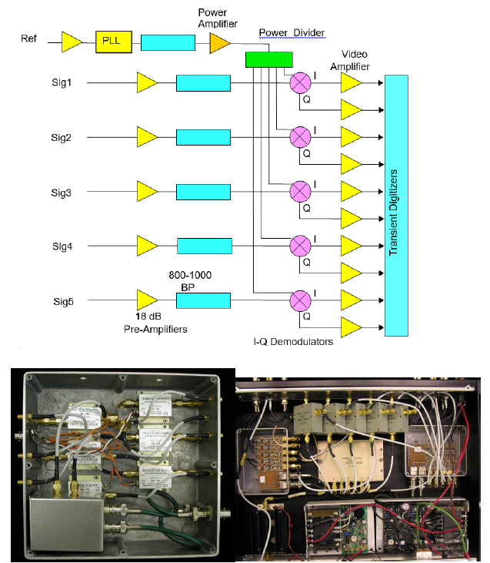

Figure. 4. Schematic of Back-End of the High-k Scattering Receiver (top); Pre-Amplifier Module Containing the PLL and six 18-dB Amplifiers and IF Electronics Module from previous high-k system (bottom).

1. **High-k Poloidal Scattering Receiver System:** The high-k poloidal scattering receiver components have all been purchased and are ready for operation. The receiver system is designed around a pair of 4×1 subharmonic mixer (SHM) arrays fabricated by Virginia Diodes Inc. (VDI). Each array consists of four SHMs arranged linearly in a compact package (340x240x124 mm3) as shown in Fig. 5, with two such arrays lined end-to-end making an 8-element receiver. Each array features integral horn antennas spaced at 30 mm intervals, with a common LO port. Each SHM has a conversion loss of <13 dB (SSB) and includes an integrated IF amplifier spanning 800-1000 MHz with a ~0.6 dB noise figure. Supplied with each array is an Amplifier/Multiplier Chain that delivers >600 mW LO power at 155.5 GHz.

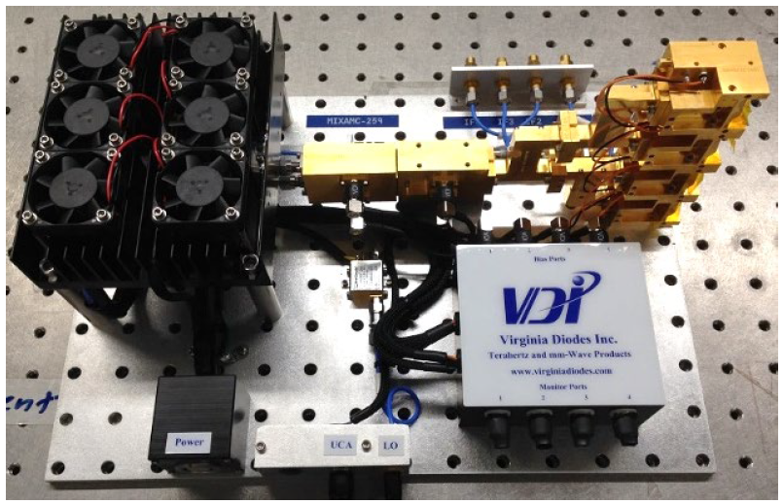

Figure. 5. Photograph of a VDI 4×1 SHM array for high-k receiver system. There are two bundles employed on full scattering system for 8 channels measurement.

1. **High-k Poloidal Scattering Receiver Stage:** Density ﬂuctuations along the launch beam path cause the beam to primarily scatter poloidally — the high-k receiver optics collect the scattered waves and image them onto an 8-channel receiver with each channel corresponding to a diﬀerent poloidal scattering angle. The 4-axis receiver stage is designed to adjust the receiver angle to achieve different k- spectrum measurement, the adjustment ability and real photo are shown in Fig. 6.

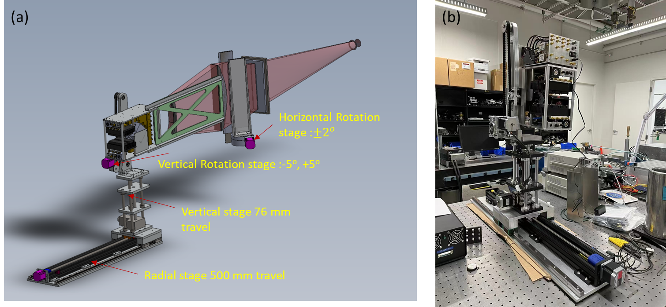

Figure 6. (a) CAD rendering showing the modiﬁed 4-axis high-k receiver carriage, translated radially to place the pivot point (interaction region) deepest into the NSTX-U plasma, (b) real product photo of receiver stage.

1. **Pressure monitor for high-k poloidal scattering system and FIReTIP:** Both systems use a thermocouple and convection gauge to measure pressure in the waveguide tube, with a minimum pressure capability of 1 mTorr and a maximum rated pressure of 2 Torr. The typical operating pressure for the FIR laser in the high-k system is approximately 160 mTorr, while that for the FIReTIP system is around 220 mTorr. The analog output voltage from the monitor can be recorded by an NI detector, converted to pressure according to relationship as shown in Fig. 7 , and monitored through a LabVIEW program.

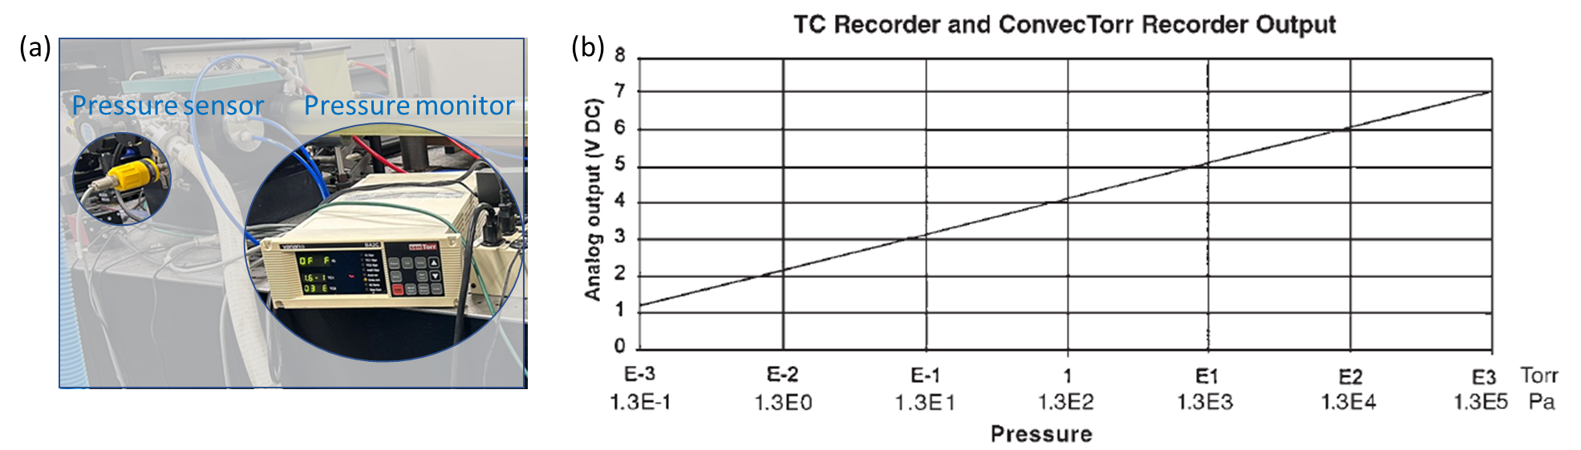

Figure 7. (a) The pressure sensor and monitor system, (b) The calibration between output voltage and pressure.

1. **Power detector for high-k poloidal scattering system and FIReTIP:** The Gentec power detector, used in conjunction with a chopper as shown in Fig. 8, is employed to measure the power evolution of the FIR laser. The QS5-IL sensor on the Gentec power detector has a broad spectral response ranging from 0.1 to 1000 μm, with a maximum average power rating of 50 mW and a noise equivalent power of 6 nW. The FIR laser wavelength of the high-k poloidal scattering system is 432 μm, with an output power of 20–40 mW, while the FIRTIP system operates at 119 μm with an output power of approximately 300 mW. This means that the Gentec power detector can be directly used for FIR power measurements in the high-k system, but additional attenuation is required for the FIRTIP system to ensure safe operation.

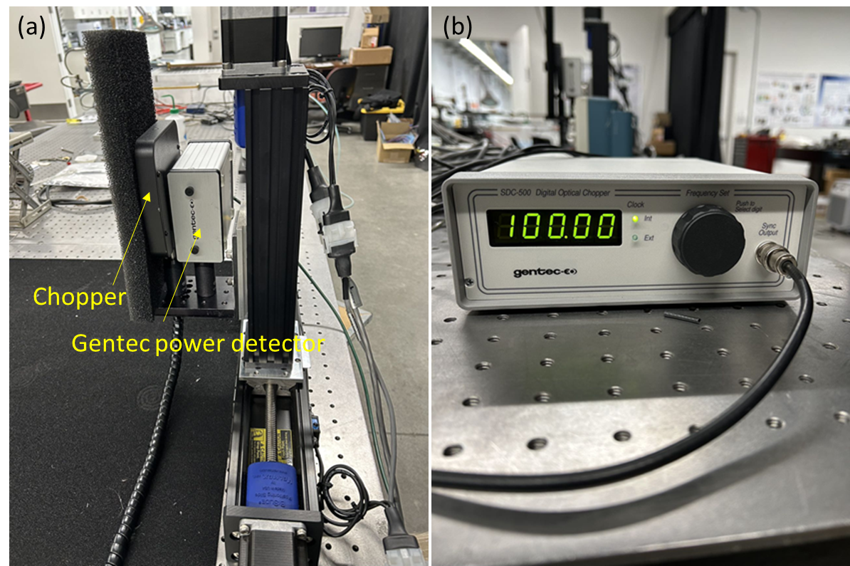

Figure 8. (a) The power detector with chopper mounted on the 2D scanning stage, (b) the control module of chopper.

The AI310 power meter & Calorimeter, as shown in Fig. 9, are used to measure the absolute power of the FIR laser for both systems. The operating parameters of the calorimeter are automatically loaded into the AI310 through the calorimeter’s intelligent connector. In normal operating mode the AI310 checks for a sensor every 15 seconds allowing for hot swapping of sensors with no user intervention required.

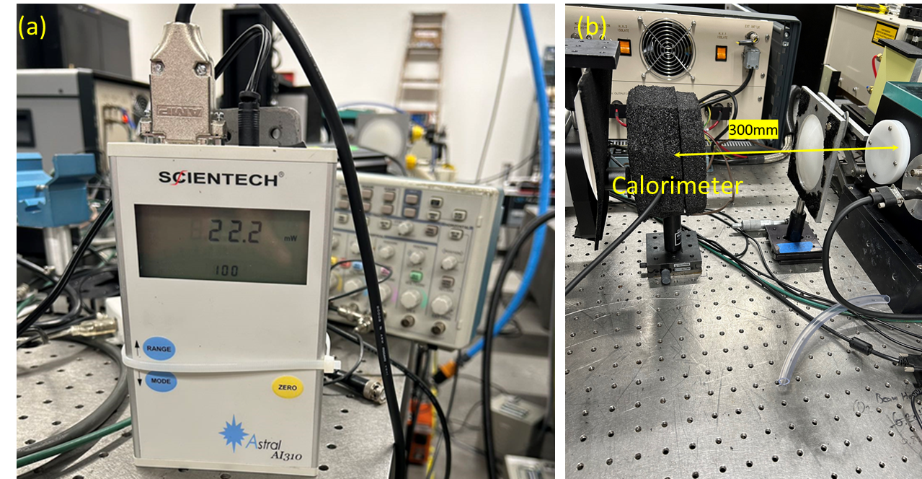

Figure 9. (a) AI 310 power meter, (b) calorimeter covered with foam used to absorb infrared waves, positioned in front of the FIR laser window for absolute power measurement.

1. **Comprehensive Test and Characterization Equipment:** In addition to the primary components, UC Davis has assembled a dedicated test platform to characterize the overall performance of the High-k system and the FIReTIP system. Figure 10 shows the setup, which is controlled via LabVIEW and used to evaluate the FIR laser output under various conditions, including changes in CO₂ laser power, methanol gas pressure, and cavity length. The overall system performance is assessed by varying individual parameters systematically. The translatable stage combined with the control system is used to measure the 2D and 3D beam profile, where a power detector records the relative intensity during the scanning process, as shown in Fig. 11.

.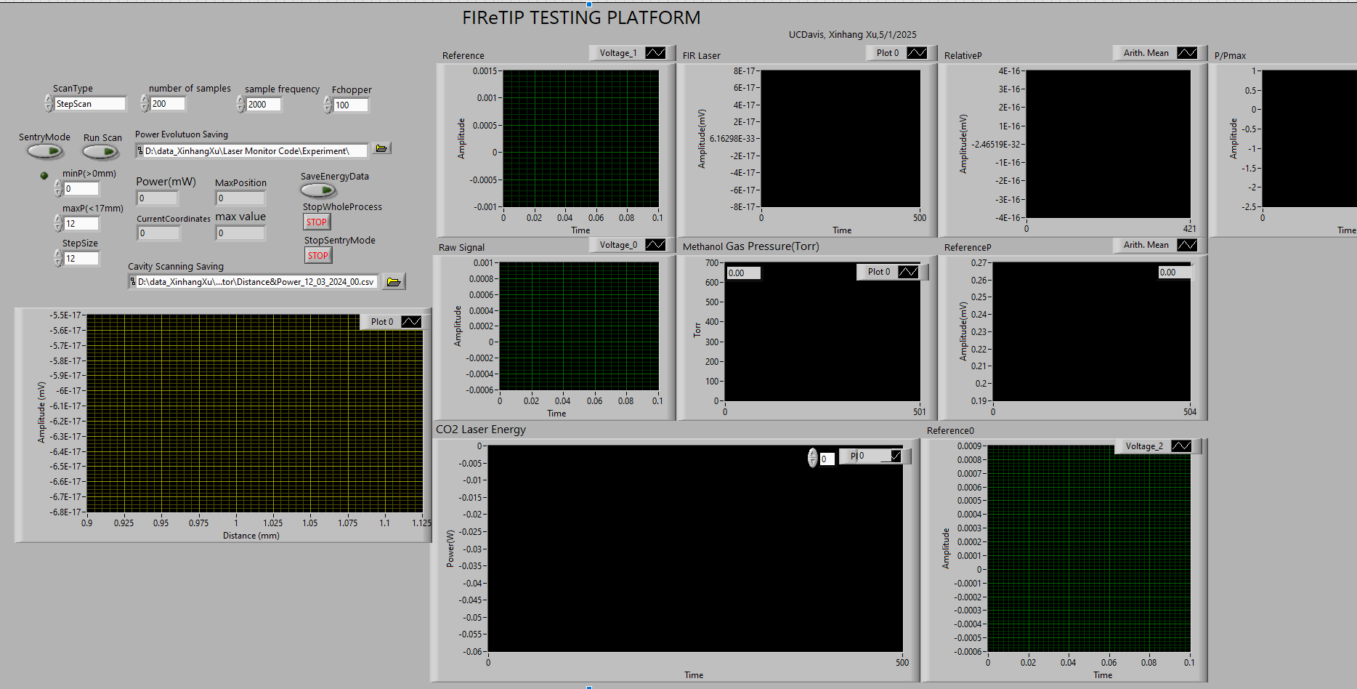

Figure. 10. Photograph of the computerized setup employed for characterizing the FIReTIP laser performance.

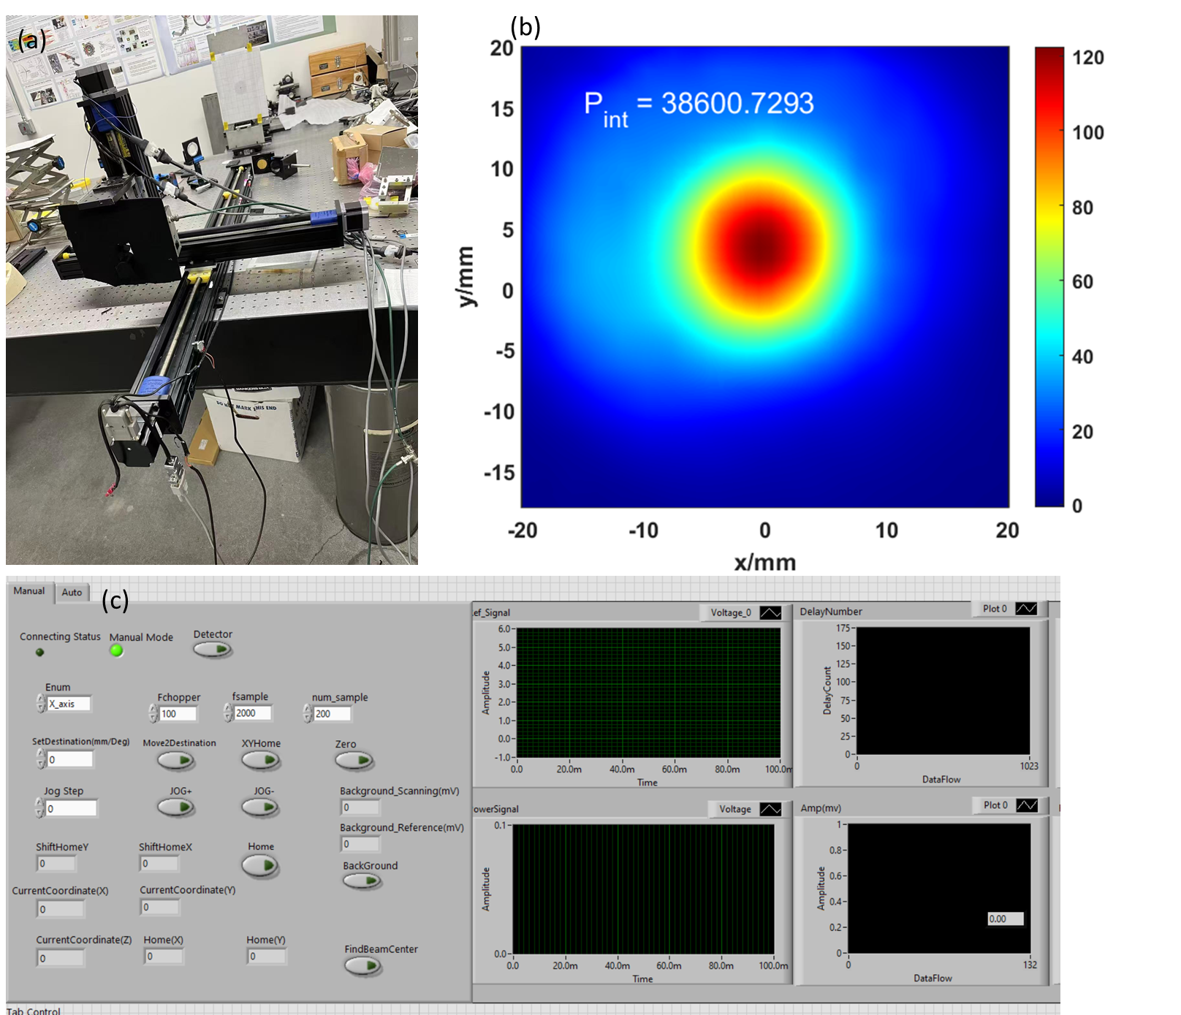

Figure 11. (a) Photograph of the FIR beam profile measurement setup, (b) an example of measured beam patterns, (c) the LabVIEW control program for beam profile measurement.

**APPENDIX IV: DATA MANAGEMENT PLAN**

Data generated by the NSTX-U diagnostics systems, including the high-k poloidal scattering and FIReTIP systems are recorded using D-TACQ high speed digitizers, then automatically transferred to PPPL servers and stored in MDS Plus, the standard architecture for data management within the magnetic fusion community. Vibration-compensated FIReTIP data, generated by the FPGA system under development by UC Davis, will be stored internally inside the FPGA during the shot and transferred to MDS Plus after each shot. Data storage is centrally managed and is contained in a dedicated project space. Data are archived using the EPICS archiver (engineering operations data repository) and using VERITAS for data backup for end users with a self-help archiving system for long-term storage. Procedure ITD-003 governs the PPPL backup policy, and it includes both on- and off-site storage; data formats include those specified by MDS Plus, NETCDF, SQL Server databases and Plasma State files. Access to all data is available both on- and off-site using MDSplus through a variety of tools, including both web-based and more conventional tools such as IDL.

UC Davis will generate, validate, and maintain data conversion routines to transform raw FIReTIP interferometry and polarimetry data into reduced form for easy analysis (interferometry data into chord- averaged density units, and polarimetry data into Faraday rotation units in degrees). Routines will be written to make MIR data also available in amplitude- and phase-fluctuation format. High-k scattering data will be left in raw form, as there are presently no reduced data formats which would significantly improve physics analysis of these data. If a suitably reduced format can be devised for high-k data in collaboration with other NSTX-U researchers, this will be supported.

All research data displayed in publications will be made digitally accessible to the public at the time of publication, as per the NSTX-U Data Management Plan. This will include data displayed in charts, figures, images, etc., and they will be identified uniquely by Digital Object Identifiers (DOIs). The DOIs and/or URLS for accessing the data files will be given in the publication. The data files will be stored in the Princeton University Data Repository. The underlying digital research data used to generate the displayed data will be made available through the establishment of a collaboration which will be established between individual researchers and PPPL.

**Appendix V: SYNERGISTIC ACTIVITIES**

Neville C. Luhmann Jr. (Lead PI)

ITER Science Fellow, International Advisory Committee of "The Cooperative Innovation Center on Terahertz Science", NEDO Project: Development of Microwave/Millimeter-Wave Diagnostic Systems and their Industrial Application, KASTEC (Art, Science and Technology Center for Cooperative Research, Kyushu University, Member of the International Organizing Committee of the International Conference on Infrared, Millimeter and Terahertz Waves (IRMMW-THz), Member of the Editorial Board of Microwave and Optical Technology Letters.

**Appendix VI: TRANSPARENCY OF FOREIGN CONNECTIONS**

**University of California, Davis**

|  |  |
| --- | --- |
| **Disclosure Information** | |
| **Entity Name** | University of California, Davis |
| **Website Address** | https://www.ucdavis.edu/ |
| **Mailing Address** | One Shield Ave. Davis, CA, 95616 |
| **Project Participants Party to ANY Malign Foreign Talent Recruitment Program** | None |
| **Country of Risk Joint Venture or Subsidiary** | Not applicable |
| **Current or Pending Foreign Contractual or Financial Obligation** | Not applicable |
| **Percentage Foreign Ownership or Control** | Not applicable |
| **Percentage Country of Risk Ownership** | Not applicable |
| **Percentage Country of Risk Investment** | Not applicable |
| **Country of Risk Technology Licensing of Intellectual Property Sales** | None |
| **Foreign Equipment** | None |
| **Foreign Entity Relationships** | Not applicable |
| **List of Company Directors (and Board Observers)** | Not applicable |
| **Complete Capitalization Table** | Not applicable |
| **Principal Place of Incorporation** | Not applicable |
| **Rounds of Financing Table** | Not applicable |
| **Organization Chart** | Not applicable |

**Appendix VII: OTHER ATTACHMENTS**

**Letters of collaboration or access**

